

Neuroendocrinology
Costanzo Moretti MD and Mozhgan Ebrahimi

www.endocrinologiamoretti.it

Notes from lessons

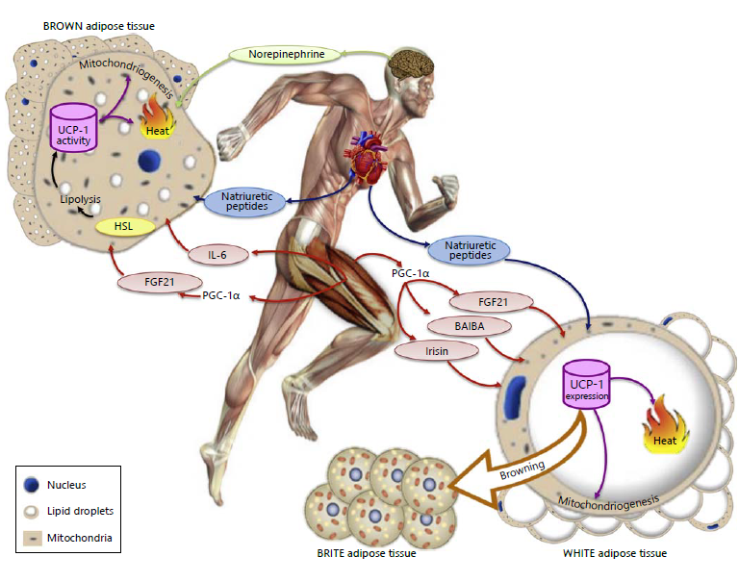

name | Abbreviations
Hypothalamus–pituitary–adrenal | HPA
Hypothalamic-pituitary-testicular | HPT
Total cortisol | C
Total testosterone | TT
Free testosterone | FT
estradiol | E2
interleukin 6 | IL 6
tumor necrosis factor | TNFα
growth hormone | GH
Insulin-like growth factor 1 | IGF-I
glucocorticoid receptor | GR
mineralocorticoid receptor | MR
Luteinizing hormone, also known as lutropin | LH
Follicle-stimulating hormone | FSH
Adrenocorticotropic hormone | ACTH
Sex hormone binding protein | SHBG
corticotropin releasing hormone | CRH
Gonadotropin-releasing hormone | GnRH
white adipose tissue | WAT
brown adipose tissue | BAT
fatty acids | FAs
free fatty acids | FFAs
triacylglycerol | TG
arginine vasopressin; also known as antidiuretic hormone [ADH] | AVP
paraventricular nucleus | PVN
Neuropeptide Y | NPY
Dehydroepiandrosterone | DHEAS
Cerebrospinal fluid | CSF
Body mass index | BMI
acylation stimulating protein | ASP
fasting-induced adipose factor | FIFA
Maximal oxygen uptake | VO2max
Metallothionein | MT
suprachiasmatic nucleus | SCN
central nervous system | CNS
sympathetic nervous system | SNS
autonomic nervous system | ANS
Trier Social Stress Test | TSST
adenosine triphosphate | ATP
Luteinizing Hormone-Releasing Hormone, also called gonadotropin-releasing hormone | LHRH
triiodothyronine | T3

  - Neuroendocrinology: The Interface between Neurobiology and Endocrinology
Neuroendocrine systems direct a wide variety of critical biological processes such as growth and development, energy and fluid homeostasis, responses to stress, and reproduction. Neurons are highly specialized and morphologically diverse cells that transmit information via electrical impulses called action potentials. Neurons have a cell body containing the cell nucleus, mitochondria, and synthetic organelles. Neurons also have cell processes that participate in the reception and delivery of electrical impulses. Dendrites are short processes often extensively branched to increase surface area that typically receive information (afferent electrical impulses). The axon is a single cell process that generally transmits efferent electrical impulses away from the cell body in a process called “neuronal firing(1).
Neuronal signals are transferred across neuron-to-neuron connections (synapses) via chemical neurotransmitters. This process begins with bursts of neuronal firing, which results in the opening of voltage-gated calcium channels at the axonal terminal. The influx of calcium promotes exocytosis of neurotransmitter-containing synaptic vesicles, releasing neurotransmitters into the synaptic cleft. Neurotransmitters then bind to specific ligand-dependent ion channels in the postsynaptic membrane, which can stimulate an action potential in the postsynaptic cell membrane(1). Wide variety of factors serve as neurotransmitters, including amino acids (acetylcholine, glutamate, aminobutyric acid [GABA]), biogenic amines ( norepinephrine, epinephrine, dopamine, serotonin), and neuropeptides (kiss-peptin, neurokinin B, dynorphin, somatostatin, proopiomelanocortin [POMC], neuropeptide Y(1). Bursts of neuronal firing can also elicit release of neuronal products into the bloodstream to influence remote targets(1).
Hypophysiotropic neurons are specialized hypothalamic neurons that secrete peptide releasing factors GnRH, corticotropin releasing hormone (CRH), thyrotropin-releasing hormone (TRH), and growth hormone-releasing hormone (GHRH) into the hypophyseal portal circulation. These releasing factors in turn stimulate specific anterior pituitary cell populations(1).
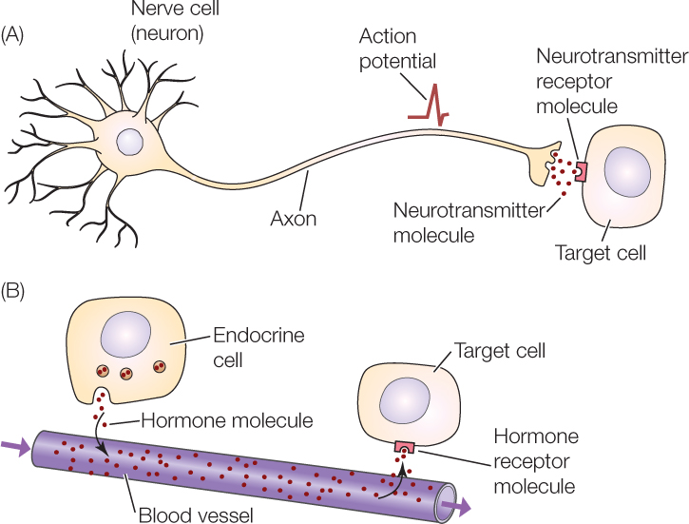

  - Hypothalamic–pituitary–adrenal (HPA) axis:
This is a complex set of direct influences and feedback interactions between the hypothalamus, the pituitary gland and the adrenal gland. The key elements of the HPA axis are the hypothalamic paraventricular nucleus, the anterior lobe of the pituitary gland and the adrenal cortex(2). Major functions of the HPA include: (i) influencing fetal development of major organ systems including lung, liver, and gut, (ii) metabolic functions, including the maintenance of normal blood glucose levels during the fasting state via glycogenolysis and gluconeogenesis, (iii) modulation of immune function, and (iv) maintenance of cardiovascular tone(3).
    - Hypothalamus
The hypothalamus is located at the base of the brain although small (approximately 10 grams, less than 1% of total brain weight), it performs critical functions for maintenance of whole-organism homeostasis. In particular, primary functions include regulation of hunger and weight maintenance, various aspects of metabolism, growth, thirst and renal water handling, body temperature, autonomic function, sleep, circadian rhythms, and emotion. Importantly, the hypothalamus is also a primary control center for reproduction and influences sexual behavior(1).
As an anatomical structure, the hypothalamus does not have discrete borders; but in general, it forms the floor and inferior lateral walls of the third ventricle. The medial portions of the hypothalamus are primarily made up of cell bodies, while the lateral portions are mostly composed of neuron fibers (axons), such as those connecting the medial hypothalamus to other areas of the brain. (Note that the hypothalamus is extensively interconnected with other brain areas(1).
    - Median Eminence
Positioned at the base of the third ventricle, the median eminence is part of the anatomical link between the hypothalamus and anterior pituitary. The median eminence represents a key access point for central sensing of peripheral cues(1).
    - Hypophyseal Portal Circulation
No direct neuronal connections exist between the hypothalamus and the anterior pituitary. However, the hypophyseal portal circulation (hypothalamic-hypophyseal portal system, pituitary portal system) represents the functional connection between the median eminence and anterior pituitary(1).
    - Pituitary Gland (Hypophysis)
The pituitary gland appears as an extension at the base of the hypothalamus and resides cradled within the sella turcica, a saddle-like structure of the sphenoid bone. The adenohypophysis (anterior pituitary) is comprised primarily by the anterior lobe (pars distalis), which contains specialized cell populations that produce specific hormones: gonadotropes (the gonadotropins LH and FSH), mammotropes (prolactin), corticotropes (adrenocorticotropic hormone), thyrotropes (thyroid stimulating hormone [TSH]), and somatotropes (growth hormone)(1).
In contrast to the adenohypopysis, the neurohypophysis (posterior pituitary) is comprised of neural tissue and forms as a downward extension of neuroectodermal tissue from the infundibulum during embryological development. It is thus a direct extension of the hypothalamus. The neurohypophysis includes the infundibular stalk and the pars nervosa (posterior lobe of the pituitary)(1).
The supraoptic and paraventricular nuclei include magnocellular neurons that produce oxytocin and arginine vasopressin [AVP]; also known as antidiuretic hormone [ADH] respectively; these axons project to the posterior lobe of the pituitary, where oxytocin and AVP are secreted into a capillary network that drains into the hypophyseal veins (directly into the general circulation). The posterior lobe also includes specialized glial cells called pituicytes, which envelope or retract from magnocellular nerve terminals during high and low neuronal activity, respectively(1).
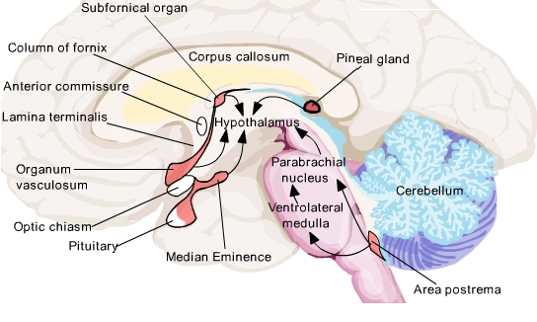

1.3 Anatomy of the Reproductive Hypothalamic-Pituitary Axis
Portions of the hypothalamus and anterior pituitary gland constitute the primary effector arm of the central reproductive axis. In particular, hypothalamic neural systems regulate GnRH release into the hypophyseal portal veins, with GnRH being the signal to gonadotropes (anterior pituitary) to secrete LH and FSH. Together, these two gonadotropins direct the primary functions of the reproductive axis: gametogenesis and gonadal sex steroid synthesis (1).

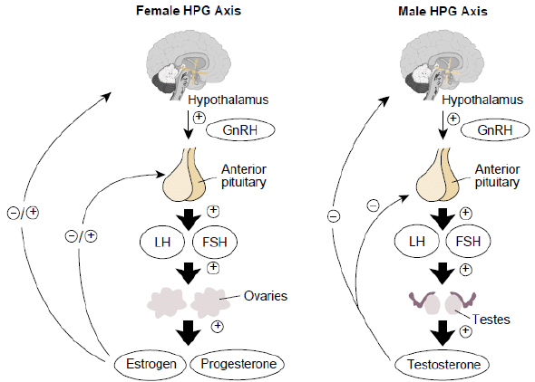

  - HPA Axis-Rhythms
The HPA axis is a major component of the systems that respond to stress, by coordinating the neuroendocrine and autonomic responses. Tightly controlled regulation of HPA responses is critical for maintaining mental and physical health, as hyper- and hypo-activity have been linked to disease states(4).
The HPA axis begins at the level of the PVN of the hypothalamus. More specifically, afferents conveying stress- and homeostatic-related information in the brain ultimately converge on the medial parvocellular neurones of the PVN. Several additional cell types are housed within the PVN, including the dorsal- and medioventral-parvocellular (dp and mpv), and posterior magnocellular neurones (PM), subserving autonomic and posterior pituitary function, respectively. The medial parvocellular neurones of the PVN represent the neuroendocrine arm of the HPA axis, comprising the final common pathway through which the brain drives the anterior pituitary corticotropes to synthesize and release ACTH which in turn, stimulates the synthesis and release of adrenal glucocorticoids, corticosterone in the rat and cortisol in humans and nonhuman primates(5).
The activity of the HPA axis increases when the organism is exposed to stress. This stress response is initiated by the activation of several afferent neural pathways, including those originating from limbic and brain-stem structure. Which in turn induce the release of CRH and AVP from parvocellular neurons of the hypothalamic PVN. Upon stimulation, these neuropeptides are released from neuronal terminals at the level of the median eminence into the portal vessels via the portal circulation, CRH and AVP reach the anterior pituitary, where they bind to their specific receptors, CRH receptor 1 (CRHR1) and AVP 1B receptor (V1bR), respectively, To stimulate the release of ACTH from corticotroph cells into the general circulation. ACTH, in turn, stimulates the adrenal gland to produce and secrete glucocorticoid hormones(6).
The adaptive response to stress and the duration of elevated glucocorticoid levels are dependent on a number of factors, including the type, intensity, and duration of the stressor, as well as time of day, sex, age, strain, prior history of stress, and state of the organism(4).
In summary, HPA axis activity is further regulated by other brain regions via direct and multisynaptic connections to the PVN. The PVN integrates excitatory inputs from brainstem regions relaying autonomic, somatosensory, and arousal signals and from circumventricular organs transmitting information from the blood and cerebrospinal fluid(4).
  - Circadian Rhythms
Circadian rhythms refer to biological oscillations with a period of approximately 24 hours. Circadian rhythms are characteristic of a number of biochemical, physiological, endocrine, and behavioral functions, and this allows the organism to anticipate and prepare for predictable environmental changes. In mammals, circadian rhythms are generated and synchronized by a central clock in the SCN of the ventral hypothalamus. The activity of the SCN is entrained by the light input received from the retina via the retino-hypothalamic tract, and this allows our physiology to be entrained to solar time. Signaling between the SCN and the periphery involves both hormonal and neuronal mechanisms(6).
In addition to the central master clock in the SCN, clock genes are expressed rhythmically in peripheral tissues, including liver, kidney, skeletal muscle, lung, and adrenal. While the SCN can independently generate and maintain its own circadian Rhythms, peripheral clocks require SCN-dependent drive to maintain synchronicity with the light-dark cycle(6).
  - Ultradian rhythms of the HPA axis
The mechanisms generating the ultradian pulsatile dynamics of the system remain poorly understood. Observations of pulsatile CRH have led to a general acceptance that a ‘hypothalamic “pulse generator”’ drives the ACTH and glucocorticoid ultradian rhythm. the hypothesis that a systems-level dynamic balance between positive feed-forward and negative feedback provides a mechanism for generating ultradian oscillations in ACTH and glucocorticoid hormone secretion has been supported by both mathematical modeling and experimental data and these findings provide good evidence for an oscillating mechanism outside the central nervous system. The pituitary-adrenal system is characterized by both a positive feed-forward pathway whereby pituitary ACTH drives glucocorticoid release from the adrenal cortex, and a negative feedback mechanism through which adrenal glucocorticoids feedback on the anterior pituitary to inhibit ACTH release. Studies suggest that sex steroids can affect the glucocorticoid ultradian rhythm by modulating both hypothalamic CRH drive and GR-mediated glucocorticoid negative feedback. Recent studies have shown that the ultradian rhythm of corticosterone secretion is not only observed in the blood but also in tissue targets such as the brain and subcutaneous tissue (3).
Overall The HPA axis is a highly dynamic system. Ultradian rhythmicity emerges due to the interaction between the dynamic release of hypothalamic hormones and an intrinsically oscillating pituitary-adrenal network. These pulsatile patterns of hormone are vital for maintaining homeostasis, stress responsiveness, and optimal metabolic and cognitive function (3).
  - Corticotrophin-releasing Hormone (CRH)
(CRH), a 41-amino acid peptide, plays a pivotal role in the coordination of the stress response and the regulation of the immune/ inflammatory reaction. In the CNS, CRH modulates the synthesis and release of ACTH and mediates together with norepinephrine many hormonal, autonomic, behavioral, and immunological effects of stress(7). CRH is the major hypothalamic activator of the HPA axis(3). CRH is present in the nerve cell bodies in and near the dorsomedial parvicellular division of the PVN of the hypothalamus. These neurons send axons to the median eminence and other hypothalamic and midbrain targets. CRH expression has also been localized in many other parts of the CNS including the cerebral cortex, limbic system, cerebellum, locus coeruleus of the brain stem, and dorsal root neurons of the spinal cord. It is also present in the adrenal medulla and sympathetic ganglia of the autonomic nervous system, as well as in the fetal lung, the T-lymphocytes of the immune system, and the gastrointestinal tract(3).
    - Regulation of CRH secretion
A number of neurotransmitters have been implicated in both the positive and negative regulation of CRH release. Acetylcholine, norepinephrine, histamine, and serotonin Increase hypothalamic CRH release, while gamma aminobutyric acid inhibits it. Additional factors that have been implicated in the regulation of CRH release include, angiotensin, vasopressin, neuropeptide-Y, substance P, atrial natriuretic peptide, activin, melanin concentrating hormone, β-endorphin, and possibly CRH itself. In addition, cytokines such as interleukin-1β, tumor necrosis factor, eicosanoids, and platelet-activating factor have all been shown to activate the HPA axis by increasing hypothalamic CRH expression(3).
1.7.2 CRH receptors
CRH binds to sites in the anterior lobe of the human pituitary that correlate with the distribution of corticotrophs. CRH receptors in the anterior pituitary gland are low capacity, high affinity receptors(3). Mammalian CRH receptors have been differentiated broadly into two major types, CRH1 and CRH2; each type exhibiting a 70% sequence homology and also possessing molecular splice variants. Consistent with structural differences. CRH receptors belong to the family of class ‘B’ G-protein coupled receptors(8). CRH-R1 is expressed throughout the brain, being concentrated on anterior pituitary corticotrophs. The distribution of the CRH-R2 splice variants, in contrast, is quite distinct. CRH-R2a is expressed exclusively in the brain, being more widely distributed than CRH-R1. CRH-R2b is expressed primarily in the periphery, with the highest levels found in heart and skeletal muscle. The distinct localization of these receptor types suggests they may have functionally different roles(3).
    - CRH function:

- Endocrine system
CRH is the key factor in the HPA axis leading to the release of ACTH, which acts on the adrenal cortex to release glucocorticoids and other steroid hormones including androgens and to a lesser extent aldosterone. CRH can also directly stimulate glucocorticoid release from the adrenal gland. Vasopressin, co-synthesized with CRH in hypothalamic PVN neurons, acts in concert with CRH to stimulate ACTH secretion. CRH, acting via the type 1 CRH receptor, stimulates adenylate cyclase activity increasing cAMP levels in anterior pituitary corticotrophs. CRH stimulates ACTH release via the cAMP-protein kinaseA pathway, which is responsible for both the increase in pro-opiomelanocortin (POMC) transcription and peptide synthesis, as well as for the rise in intracellular calcium, results in ACTH secretion(3).
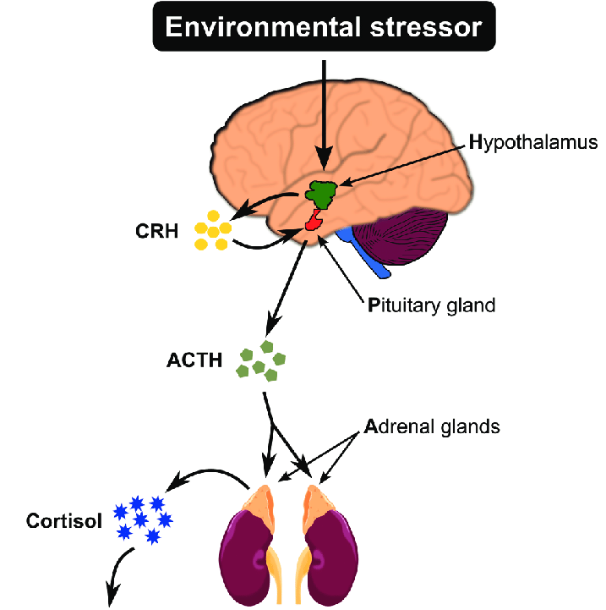

- Behavioral effects
As an important integrator of the stress-response, CRH and CRH-related peptides have been implicated as mediators of behavioral responses to stress. CRH is present within the amygdala, an area of the brain, which mediates behaviors associated with fear and anxiety, such as decreased appetite(3).
- Immune system
There is increasing evidence that the neuroendocrine system and the immune system work together in the regulation of both the stress and the immune response. CRH is thought to have both direct and indirect effects on the immune system. Indirectly, CRH may down regulate inflammation through the release of glucocorticoid, whereas a direct pro-inflammatory action of CRH may occur in peripheral tissues. These direct actions are not completely understood but may include: mast cell degranulation, nitric oxide-dependent vasodilatation, enhanced vascular permeability, leukocyte proliferation, and cytokine release by activated leukocytes(3).
- Reproductive system
There is considerable evidence that stress has a major negative effect on reproduction. As part of the neuroendocrine response to stress, CRH has been implicated as a major inhibitor of reproductive function in both sexes. Intense or prolonged stress, for example, has been shown to inhibit gonadotropin secretion. Additional central effects include attenuation of sexual behavior(3).
- Stress-response
Stress, defined as a state of threatened homeostasis, mobilizes a complex spectrum of adaptive physiologic and behavioral responses that aim to re-establish the challenged body homeostasis. The HPA axis and the SNS constitute the main effector pathways of the stress system, mediating its adaptive functions. Recent data indicate that chronic stress, associated with mild hypercortisolemia and prolonged SNS activation, favors accumulation of visceral fat and contributes to the clinical presentation of visceral obesity, type 2 diabetes, and related cardiometabolic complications(9).
The adaptive response to acute stress is critical for the survival of the individual. Prolongation of this response, however, as in chronic stress, can have detrimental effects on whole body metabolism and, especially, on glucose homeostasis, growth, reproduction, and immunocompetence. Glucocorticoids and catecholamines, the principal hormonal effectors of the stress system, appear to mediate these effects over time, progressively leading to various manifestations of the metabolic syndrome. Growing evidence suggests a significant positive association between increased cortisol levels and weight gain .Thus, chronic hypercortisolemia may contribute to visceral fat accumulation and insulin resistance (9).
The stress-response is classically divided into three categories: behavioral, autonomic, and hormonal responses. Behavioral responses govern the conscious response to a stressor, and include fear, anxiety, and heightened vigilance, clarity of thought, anorexia, and decreased libido. Autonomic responses, mediated by the sympathetic nervous system, mobilize certain organ systems to carry out fight or flight activities. These include increased heart rate, cardiac output, breathing rate, and bronchodilation, increased blood flow to brain and muscle, decreased blood flow to skin and gut, activation of innate immunity, maintenance of blood glucose, and increased free fatty acid generation. Hormonal responses largely provide fuel for these activities (during a time of induced anorexia) and include, maintenance of blood glucose, increased free fatty acid generation, maintenance of blood pressure, and restraint of the immune system. CRH is likely involved in all three types of stress-response. Behavioral responses may involve CRH present in the cerebral cortex and amygdala. Autonomic responses are controlled in part by brainstem fibers descending from the locus coeruleus, which receives CRH-containing fibers from the amygdala and paraventricular nucleus. Hormonal responses center on activation of the HPA axis, which is initiated by CRH present in the PVN (3).
I. CRH AND ACUTE STRESS
In response to stress, the amplitude and synchronization of the CRH and AVP pulsations in the hypophyseal portal system increase markedly. This leads to increased ACTH and cortisol secretory episodes. Depending on the type of stress, other factors such as AVP of magnocellular neuron origin, angiotensin II, and various cytokines are secreted and act on hypothalamic, pituitary, or adrenal components of the HPA axis, potentiating its activity (10).
High stress-induced CRH secretion will lead by an intra hypothalamic pathway to inhibition of sexual and feeding behavior and to the inhibition of the growth hormone and reproductive hormonal system. Cortisol inhibits the growth hormone and reproductive axes in conjunction with CRH, and it inhibits immune system over activity. Available energy will be increased by promoting gluconeogenesis, glycolysis, and proteolysis, and through higher insulin resistance. CRH will stimulate norepinephrine secretion from the locus coeruleus, leading to an increase in blood pressure, heart rate, and glycemia, and a decrease in gastrointestinal blood flow. These adaptions allow the organism to cope quickly with acute stressors and threats (‘‘fight or flight reaction’’) (10).
II. CRH AND CHRONIC STRESS
In situations of chronic stress, the negative feedback of the HPA axis can fail, and a lasting CRH hyper drive can arise. Chronic CRH hyper drive is associated with numerous adverse effects on the organism. Chronic cortisol excess leads to excessive fear. Insulin resistance and visceral fat deposition increase the risk for atherosclerosis. Through the inhibition of sex steroids and growth hormone, glucocorticoids antagonize lipolysis and muscle and bone anabolism. Chronic activation of the stress system would therefore be expected to increase visceral adiposity, decrease lean body (muscle and bone) mass, and suppress osteoblastic activity (10).
  - Adrenocorticotropic hormone (ACTH)
Native ACTH is synthesized in the pituitary and functions to stimulate the adrenal cortex to release steroids into the blood stream as part of the neuroendocrine stress response. Neurons containing ACTH have been localized to the CNS, particularly the hypothalamus, and ACTH-immunoreactive cell bodies or fibers have also been described in amygdala, cerebral cortex, brainstem, and cerebellum(10). In contrast to pituitary ACTH, the functions of CNS ACTH have not been well-defined. Evidence from both human and animal studies has suggested that CNS ACTH may function as a neurotransmitter/neuromodulator. Indeed, central physiological roles for ACTH, including modulation of learning and memory processes and facilitation of arousal states, have been suggested, but the mechanisms for these actions of ACTH have not been fully elucidated. Pituitary ACTH synthesis and secretion are regulated by the peptide CRH, and both hormones participate in the neuroendocrine response to stress. Furthermore, ACTH reduces CRH gene expression in hypothalamus as part of the neuroendocrine feedback loop of the stress response(10). Adrenal responsiveness to ACTH is also altered under conditions of chronic stress, long-term voluntary exercise or aging (2). Exposure to prolonged intermittent stress results in both adrenal hypertrophy and hyperplasia, which contribute to an enhanced maximal response to ACTH without affecting adrenal sensitivity (2).
  - Glucocorticoids
Glucocorticoids are synthesized in the zona fasciculata of the adrenal cortex. Glucocorticoids exert primarily catabolic effects, recruiting all available energy resources to defend body homeostasis against the imposed stressor. Thus, hepatic gluconeogenesis is enhanced, circulating glucose levels are increased and lipolysis is induced. Additionally, protein degradation is promoted at multiple tissues (muscle and bone) to provide amino acids which can serve as an additional substrate for oxidative pathways. Furthermore, glucocorticoids antagonize the anabolic actions of growth and thyroid hormones, insulin and sex steroids on their target tissues. This stress-related metabolic shift toward a generalized catabolic state typically reverses upon retraction of the posed stressor (9). In contrast to peptide hormones, which are presynthesized and stored within the cytoplasm and released upon activation, glucocorticoids are synthesized upon stimulation of the adrenal. Once released into the blood circulation, glucocorticoids access target tissues, such as the liver, the heart and vascular tissues, to exert metabolic and cardiovascular effects, respectively, and the brain, where for example, glucocorticoids promote cognitive processes necessary to cope with a threatening situation. Glucocorticoids also regulate the activity of the HPA axis, and thus their own production, through feedback mechanisms, acting at the level of the pituitary gland where they inhibit ACTH release, and at the level of the PVN where they inhibit the synthesis and release of CRH and AVP. In addition, glucocorticoids indirectly regulate HPA axis activity via modulation of other brain structures, including the hippocampus, the amygdala, and the prefrontal cortex, which in turn regulate the activity of the PVN(6).
    - Glucocorticoid receptors
Glucocorticoids exert their effects by binding to specific receptors expressed in target tissues. Two receptors for glucocorticoids are known: the glucocorticoid receptor (GR) and the mineralocorticoid receptor (MR). These receptors belong to the superfamily of nuclear receptors(6). Approximately 95% of glucocorticoid molecules become bound to carrier proteins, the remaining fraction of circulating corticosterone is unbound and free to diffuse across cell membranes and bind to intracellular GRs and MRs in target tissues(6).
Glucorticoids bind GR and MR with different affinity. The affinity of the endogenous hormones corticosterone and cortisol for MR is approximately 10-fold higher than the affinity for GR. Therefore, variations in circulating levels of glucocorticoids lead to shifts in the balance between MR and GR activity. The high-affinity MR is activated at very low concentrations of glucocorticoids, whereas the lower affinity GR is only activated at high concentrations. In basal (nonstressed) physiological states, when glucocorticoid concentrations are low, MR is activated and localized in the nucleus, whereas GR remains latent in the cytoplasm. Once glucocorticoid concentrations increase above a threshold level, for example during the circadian peak or following exposure to stress, GR translocates into the nucleus where it exerts its genomic effects. Differences between MR and GR are also found in their distribution throughout the body. While GR is ubiquitously expressed in the periphery and in the brain, the distribution of MR is more localized to specific organs such as the kidney and the heart (6). In the brain, the distribution of these receptors is also not uniform. GR is almost ubiquitously expressed in neurons and glial cells, with particularly high density in the hippocampus and in parvocellular neurons of the PVN. In contrast, MR localization is restricted to the hippocampus, prefrontal cortex, and amygdala Significantly both receptors are expressed abundantly in areas regulating the HPA axis, including a number of limbic structures that regulate the activity of the PVN, such as the hippocampus and amygdala, as well as in the anterior pituitary (6).
    - Circadian Rhythm of Glucocorticoid Secretion
Consistent with other circadian physiological functions, the circadian rhythm of the HPA axis is primarily regulated by the central pacemaker located in the SCN. The SCN regulates the circadian rhythm of glucocorticoids in part by modulating the release of CRH from neurons in the PVN, and in part via the autonomic nervous system (ANS) through a multisynaptic neural pathway from the SCN to the adrenal gland. Additionally, there is evidence of an intra-adrenal circadian pacemaker that can regulate glucocorticoid synthesis independently from the SCN. In turn, circadian secretion of CRH regulates circadian release of ACTH from the anterior pituitary gland. Number of studies have demonstrated a role for vasopressin release from the SCN in modulating HPA circadian activity. Vasopressin-containing neurons in the dorsal SCN have been shown to be an important component of the SCN output. In addition to the SCN, key components of the HPA axis, including the PVN, pituitary, and adrenal cortex, express circadian clock genes(6).
  - Cortisol
cortisol is the main adrenal glucocorticoid in humans, Along with norepinephrine and epinephrine, glucocorticoids promote the adaptation to stress (classically known as the “fight or flight” response, They act to increase sympathetic activity by stimulating glucose release and gluconeogenesis, in concert with stimulation of cardiovascular and pulmonary function, including increased heart rate, blood pressure, and respiration. Simultaneously, anabolic processes, such as immune function, reproduction, digestion, and growth, are suppressed. In addition, by binding to the GR, type II, glucocorticoids exert negative feedback effects on the HPA axis at the level of the hippocampus, PVN, and pituitary to dampen further glucocorticoid release and terminate the response efficiently (2). Glucocorticoids feedback on the hypothalamus and pituitary gland to suppress CRH and ACTH secretion. In all species studied, both ACTH and glucocorticoids are secreted in a pulsatile fashion(2).

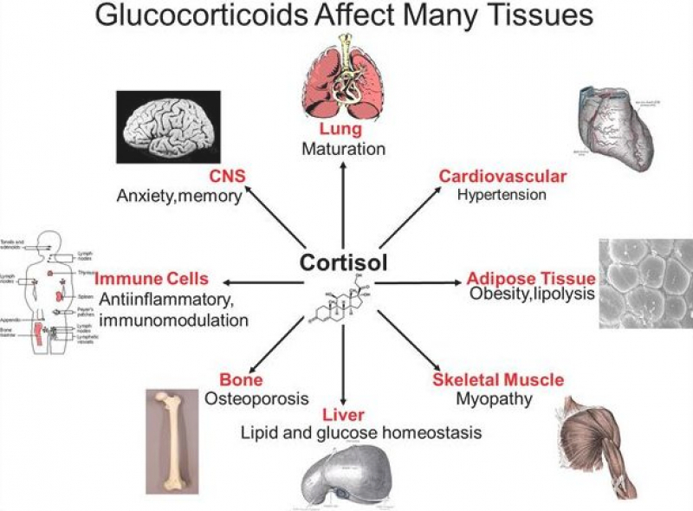

  - Gonadotropin-Releasing Hormone: The Neuroendocrine Pathway for the Central Control of Reproduction
Gonadotropin-releasing hormone, previously called luteinizing hormone-releasing hormone (LHRH), is synthesized and released from a relatively small population of specialized hypothalamic neurons. Although the primary function of GnRH is to regulate pituitary gonadotropin secretion, GnRH also appears to have autocrine and paracrine functions in diverse tissues(1).
The arcuate nucleus of the medial basal hypothalamus is a central relay station for body fat signaling and is a site of GnRH release. The specialized cells that synthesize and secrete gonadotropins (gonadotropes) are located mainly in the lateral portions of the anterior pituitary gland and constitute 7% to 10% of the adenohypophysis cell population. Numerous neurotransmitters appear to be involved in the regulation of GnRH secretion, including dopamine, norepinephrine, glutamate, GABA, and nitric oxide(1). NPY facilitates GnRH release and gonadotropin responsiveness to GnRH. GnRH, which then travels via the hypothalamic–hypophyseal portal circulation to the anterior pituitary gland, where it binds to the GnRH receptor and up-regulates synthesis and secretion of two pituitary LH and FSH hormone. Gonadal functions, gametogenesis and steroidogenesis, are regulated by GnRH, LH and FSH (1). GnRH secretion is pulsatile, with discrete bursts of GnRH effecting the release of pulses of LH and FSH by the pituitary. The secretion of LH and FSH is also regulated by direct negative feedback from gonadal products (estradiol [E2], inhibin A and B). Once released from the pituitary, LH and FSH travel through the systemic circulation to stimulate sex steroid production and gametogenesis by the gonads. The patterns of hypothalamic, pituitary, and gonadal activity are responsible for the transition from childhood to adulthood, as well as for normal ovulatory cycles in postmenarchal women and normal sexual function in males(1).
GnRH preferentially stimulates FSH secretion in childhood and LH secretion in infancy, puberty, and adulthood. Like GnRH, kisspeptin stimulates LH release twofold more than FSH release in healthy men. Depending on factors such as species and sex, both basal gonadotropin secretion and LH surges may exhibit diurnal rhythms (1).
Variety of human conditions associated with absent (or near-absent) GnRH secretion lead to pubertal failure, hypogonadotropic hypogonadism, and infertility. GnRH secretion is influenced by numerous factors including sex steroids, energy availability, and stress. Pulsatile GnRH secretion is absolutely required for long-term stimulation of gonadotropin synthesis and secretion. Thus, intermittent GnRH stimulation facilitates or maintains gonadotrope responsiveness to GnRH. However, more frequent exposure to GnRH pulses can reduce gonadotropin responses to GnRH(1).
    - GnRH and GnRH Receptors
GnRH receptors are calcium-dependent G-protein coupled receptors (GPR’s). More than 23 different GnRH peptides exist among species. Human GnRH decapeptide exists in at least two forms designated GnRH I and GnRH II, cloned initially in mammals and chickens, respectively. GnRH I receptor is the hypophyseal receptor coupled To LH and FSH synthesis and is the predominant agonistic peptide regulating gonadotropin secretion in humans, which is encoded by a gene located on chromosome 4. The GnRH II receptor gene is located on chromosome 1, but is silenced in the human, chimpanzee, cow, and sheep. Both GnRH I (secreted) and GnRH II (brain) peptides can activate the GnRH. GnRH receptor density varies in different physiological conditions and exhibits a positive correlation with gonadotrope responsiveness to GnRH. GnRH receptor density appears to be modulated primarily by GnRH, with intermittent GnRH stimulation leading to increased GnRH receptor expression; this is a central facet of the self-priming effect of GnRH, and an important mechanism by which GnRH action is modulated in different physiological states. (1).
    - Kisspeptin
The neuroendocrine reproductive axis, composed of the hypothalamus, anterior pituitary and gonads, is now known to be regulated, apparently in large part, by kisspeptin, a product of KISS1, acting via the G protein-coupled receptor, GPR54, located on GnRH neurons(1). The kisspeptin system is believed to be requisite for normal GnRH secretion, serving as a “gatekeeper” of puberty and helping to mediate the effects of sex steroids and metabolic cues on GnRH secretion. Kisspeptin was originally called metastin because of its ability to suppress metastatic spread of human melanomas and breast carcinomas. Single boluses of kisspeptin markedly stimulate LH release in rodents, sheep, monkeys, and humans. This effect of kisspeptin is mediated by stimulation of GnRH neurons, as supported by the following: kisspeptin fibers appear to project to and form synaptic contacts with GnRH neurons, the kisspeptin receptor is expressed by a majority of GnRH neurons; kisspeptin can directly depolarize GnRH neurons; and kisspeptin stimulation of gonadotropin secretion is completely blocked by GnRH antagonists(1).
  - Sex Differences in the HPA Axis
Sex differences in the HPA axis, and the portion of the stress response that it mediates, largely arise during puberty; however, the initial development of the structures of the HPA axis is relevant to the means by which sex differences later manifest(11). Males and females of many species secrete differing levels of stress hormones following the same stimulus. The biological factors underlying the sex differences in stress responses are complex and involve several regions of the central and peripheral nervous systems. A major influence on HPA axis activity is gonadal steroids, which can impact gene expression, protein synthesis, and cellular excitability through their actions on androgen and estrogen receptors(4).
During early development, rapid increases in gonadal hormones exert “organizational” effects that permanently alter the brain and behavior. Thus, the sexually dimorphic development of brain circuits that are involved in eliciting sex differences in adult stress responses begins early in life. Release of gonadal hormones during puberty and adulthood leads to reversible modulation of behavior and physiology, including HPA function, and these effects are deemed “activational”. Additional underlying factors in these sex differences, such as the serotonin and norepinephrine systems which intersect with the HPA axis, may be secondary to gonadal influences, while other sex differences, perhaps related to the functions of the sex chromosomes, are independent. Interestingly, in humans, men appear to have greater numbers of CRH-expressing neurons in the PVN, which may explain the higher HPA responsivity to certain stressors seen in men(4).
    - Physiological stressors
Studies have found greater ACTH and/or cortisol responses in men compared to women following the Trier Social Stress Test TSST (The test consists of a 3 min preparation period, a 5 min speech, and a 5 min mental arithmetic task in front of an unfamiliar audience) and other psychological tests(4).
    - Physical stressors
In regards to physical stressors, studies show either a lack of sex differences or greater HPA activation in women. There were no sex differences in cortisol following exhaustive endurance exercise, But Physical stressors, such as heat and cold elicit greater HPA reactivity in women. Following 20 min of heat exposure, the rise in plasma ACTH and heart rate was greater in women, while the increases in cortisol and body temperature were similar in both groups(4).
    - Pharmacological stressors
Studies of pharmacological stimulation of the HPA axis appear to yield greater stress hormone output in women. ACTH and cortisol responses to administration of naloxone were greater in female subjects compared to males. Further, greater increases in cortisol secretion in women were seen after administration of dexamethasone (4).
Taken together, the type of stimulus is an important factor in determining the sex-specific patterns of HPA axis responsivity in humans and may indicate that distinct pathways to the PVN are recruited depending on the nature of the stressor. Perhaps physical or pharmacological challenges stimulate brainstem autonomic pathways to the PVN or direct secretion of hormones to a greater extent in women, while psychological stressors may activate the HPA through indirect limbic relays more potently in men(4).
Lower HPA axis activity in males may involve a greater degree of inhibitory signals relayed from limbic regions of the brain. Additionally sex differences appear to rely on greater synthesis and faster rate of replenishment of stress peptide stores in females. Both the pituitary and adrenal glands contribute to the heightened sensitivity of the HPA axis in females (4).
One of the major components of sexual dimorphism of the HPA axis relates to the capacity for releasing glucocorticoid from the adrenal gland. The difference in adrenal size appears to be due to greater volume of the zona fasciculata of the adrenal cortex, where corticosterone is synthesized. However, the size of individual cells in the zona fasciculata is the same in both sexes, indicating that the numbers of corticosterone synthesizing cells is significantly greater in females. Indeed, the capacity for corticosterone synthesis is greater in female adrenal tissue homogenates compared to male. Along with this, the adrenal secretory capacity is far greater in females than males, leading to a higher concentration of corticosterone even when the availability of ACTH is the same. Finally, there are indications of sex differences in the metabolism and clearance rate of glucocorticoids, the metabolic clearance rate of cortisol is higher in males than in females. Females synthesize and secrete higher levels of CRH compared to males, as well as show higher peak amplitudes and duration of glucocorticoid responses to stress (4).
In sum, greater stress-related peptide synthesis in the PVN, combined with heightened sensitivity of the pituitary and adrenal tissues, leads to higher responsiveness of the HPA axis in females(4).
Males typically show lower ACTH and glucocorticoid levels under both conditions. This sex difference in HPA function also is probably due to the inhibitory effects of testosterone in males. It is important to note that in many tissues, including the brain, testosterone can be metabolized to different and biologically active forms, including its aromatization to oestrogen and reduction to 5a-DHT. In the male, both oestrogen receptor isoforms, androgen receptors, as well as aromatase and 5a-reductase, exist in several brain nuclei. Testosterone secretion in males fluctuates over the course of development and ageing. These periods are also marked by extreme variations in basal and stress HPA function(5).
Men are also susceptible to the impacts of acute and chronic stress. It has been proposed that while men appear to be less prone to developing affective disorders, this protection comes with a cost of higher propensity for immune dysregulation and metabolic disease, Indeed, men are more vulnerable to stress-related adiposity, hyperglycemia, metabolic syndrome, and coronary heart disease, while women seem to be protected. Thus, women and men seem to have substantially different strategies in coping with the challenges of stress(4).
  - Adipose tissue
Adipocytes are organized in a multidepot organ called adipose tissue. Only one third of adipose tissue contains mature adipocytes. A combination of small blood vessels, nerve tissue, fibroblasts, and adipocyte precursor cells, known as preadipocytes, comprises the remaining two thirds. Mature adipocytes exist as two cytotypes, white and brown adipocytes. These two cell types are distinguished by differences in their color and function. WAT, which is yellow or ivory, contains predominantly white adipocytes; BAT, which appears brown, contains predominantly brown adipocytes. All brown and white adipose depots receive a vascular and nerve supply. Collections of white adipocytes comprise fat lobules, each of which is supplied by an arteriole and surrounded by connective tissue septae(12).
An individual adipocyte is supplied by an adjacent capillary and is additionally associated with a glycoprotein layer as well as reticular fibrils, fibroblasts, mastocytes, and macrophages. Compared with WAT, BAT contains a richer vascular tree, dense with multiple capillaries. The extensive vascularization of the tissue in combination with densely packed mitochondria at the ultra-structural Level account for its ‘‘brown’’ color. WAT and BAT are both innervated by the noradrenergic fibers from the sympathetic nervous system(12).
There are two major anatomic subdivisions, each with unique anatomic, metabolic, endocrine, paracrine, and autocrine properties: intra-abdominal or visceral adipose tissue and subcutaneous adipose tissue. In addition to the subcutaneous and visceral compartments, WAT is also found in small amounts around other organs, such as the heart, kidney, and genitalia(12).

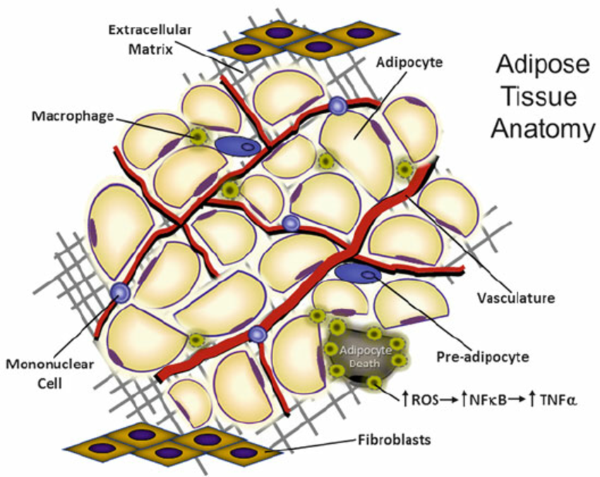

    - Principal efferent and afferent signals
Adipose tissue releases a wide range of signals, some clearly endocrine, some probably auto- or paracrine. It seems clear that this network of signals has profound and widespread effects on energy balance(13).
- Afferent signals: The principal afferent regulators of adipocyte metabolism are extrinsic to adipose tissue, and include insulin, catecholamines, and the anterior pituitary endocrine axes. Additional paracrine and autocrine regulatory influences include local adipose tissue products such as tumour necrosis factor TNFα and acylation stimulating protein ASP(13).
- Efferent signals: Adipose tissue synthesises a wide range of signalling molecules, from both the adipocyte and stromovascular compartments, include leptin, IL 6, TNFα (13).
TNFα and IL-6 are pro-inflammatory cytokines with potent actions in host defence. Both these cytokines may have important effects on lipid and glucose metabolism. In humans IL-6 was also found to stimulate glucose and fatty acid oxidation, as well as to induce the release of glucagon and cortisol. IL-6 receptors are present in the hypothalamus, which supports a direct central role for this cytokine. IL-6 stimulates both thermogenesis and satiety, through a range of central effects, including prostaglandin synthesis, CRH release and activation of the HPA axis. They stimulate the HPA axis and suppress the hypothalamic-pituitary-thyroid and gonadal axes, and possibly growth hormone release(13).
ASP may play a role in the uptake and esterication of fatty acids to make triacylglycerol to facilitate fatty acid storage in the post-prandial state. ASP has been shown to stimulate triglyceride synthesis via diacylglycerol acyl transferase (DGAT). In summary, cytokines synthesized in adipose tissue may influence anterior pituitary endocrine pathways, by contributing to circulating concentrations, which influence endocrine function at hypothalamic, pituitary, and target organ level(13).
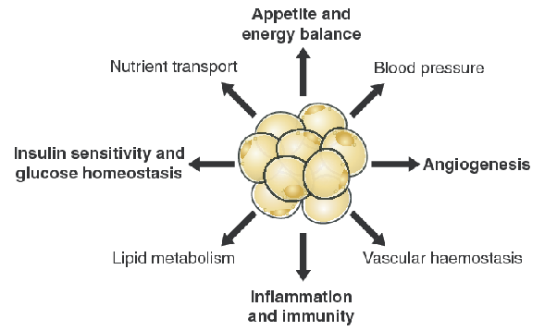

    - Brown adipose tissue
In humans, development of brown adipocytes begins at the 20th week of pregnancy and continues until shortly after birth, at which time BAT comprises 1% of body weight In neonates and newborn children, BAT can be found in several areas, including the interscapular region (shoulder), surrounding blood vessels, muscles in the neck, in the axillae, along the great vessels, trachea, esophagus at the thoracic inlet, and around the abdominal aorta, pancreas, adrenal glands, and kidneys(14). In the first decade of life there is a consistently wide distribution of brown fat. During the next six decades, active brown fat disappears from most areas but persists around the kidneys, suprarenals and aorta, and in the neck and mediastinum (4). Newborns possess large depots of BAT and use approximately 50% of their intake for cold-induced nonshivering thermogenesis. The relative functional capacity of BAT, however, appears to decrease with age and increasing size(12). Brown adipose tissue affects whole-body metabolism and may alter insulin sensitivity and modify susceptibility to weight gain. However, estimates suggest that if it were present, as little as 50 g of maximally stimulated brown adipose tissue could account for up to 20% of daily energy expenditure in an adult human (3). BAT has emerged as an independent organ with specific protein expression patterns and unique purpose. The mitochondrial protein UCP-1 (or thermogenin), which is expressed exclusively in BAT, is responsible for mediating the basic function of brown fat cells, namely the transfer of energy from food into heat. UCP-1 activity, triggered in response to adrenergic signaling via the sympathetic nervous system. On the other hand, use accumulated lipid from food primarily as a source for chemical energy that can then be released from the cell in the form of heat(12).
Thermogenesis (heat production) plays a role in all metabolic processes and consists of two major categories, obligatory and facultative. Obligatory thermogenesis is a necessary process of life and is always present, whereas facultative thermogenesis represents heat production that can be switched on and off according to the circumstances. Facultative thermogenesis consists of several subcategories: voluntary activity (exercise), non-exercise activity (fidgeting), diet-induced thermogenesis, cold-induced shivering, and cold-induced, non-shivering thermogenesis(12). The rate of UCP-1emediated thermogenesis is under control of the sympathetic nervous system, the activity of which, in turn, is governed by selective regions in the hypothalamus. The thermogenic signal (cold) is transmitted by the noradrenergic hormone norepinephrine, which is released from adrenergic nerve endings into incidental synapses adjacent to individual brown adipocytes. Norepinephrine, in turn, stimulates BAT thermogenic activity by binding to a- and b-adrenergic receptors(a-AR and b-AR), thereby triggering a cascade of events that result in multiple cell functions, including lipolysis, brown adipocyte proliferation, mitochon driogenesis, as well as increased expression and activation of UCP-1(12).
Multiple studies involving laboratory rats and mice have provided much support for BAT as an important regulator of total body fat stores. When BAT is active a considerably lower fraction of the energy consumed by the host is stored in the form of body fat, but rather is dissipated or ‘‘wasted’’ in the form of heat. Experimental models of obesity exhibit diminished or defective BAT function, as well as a failure to maintain proper body temperature when subjected to cold treatment(12).
Brown adipose tissue differs from yellow or white fat in its anatomical distribution, histological appearance, and function. The active brown fat cell has a round centrally placed nucleus and a granular cytoplasm containing multiple fat vacuoles. It is thus often referred to as multilocular, in contrast to white fat, which is unilocular. The cytoplasmic granularity depends on the large number of mitochondria in the cell. When inactive the brown fat cell becomes unilocular and indistinguishable from the white fat cell on light microscopy(14). Likewise, the morphology of white adipocytes changes progressively during fasting. Delipidized cells lose their spherical shape, elongate, and may appear multilocular(12).
    - White adipose tissue
In essence, white adipose tissue WAT is a major secretory and endocrine organ involved in a range of functions beyond simple fat storage. The classical view of the function of WAT is that it provides a long-term fuel reserve which can be mobilized during food deprivation with the release of fatty acids for oxidation in other organs. Thus, the size of the adipose tissue stores increases in periods of positive energy balance and declines when energy expenditure is in excess of intake. WAT can also provide thermal insulation. Additional functions attributed to WAT include a mechanical role, a role in inflammatory processes through preadipocytes acting as macrophage-like cells(15). Also modulate whole-body metabolism and insulin resistance(16). White adipocyte physiology can be grouped into 3 main categories with potentially overlapping mechanisms: lipid metabolism, glucose metabolism, and endocrine functions(12). Excess accumulation of white adipose tissue causes obesity(16). An endocrine role for WAT in the regulation of energy balance and other physiological processes has been established through the identification of leptin, the hormone being secreted principally from adipocytes, with actions both centrally (particularly in the hypothalamus) and in peripheral organs. Leptin is not, however, the only protein factor secreted by WAT. Indeed, there is a growing list of protein signals and factors that are released from white adipocytes, white fat plays a wide-ranging role in metabolic regulation and physiological homeostasis, far beyond the simple paradigm of fat storage(15). Many adipokines have been identified. They all integrate in a communications network with other tissues and organs such as the skeletal muscle, adrenal cortex, brain and sympathetic nervous system and participate in appetite and energy balance, immunity, insulin sensitivity, angiogenesis, blood pressure, lipid metabolism and hemostasis(17)

  - Table. Adipokines and their metabolic effects in humans
Adipocytokines | Effects on
LPL | Lipid metabolism
IL-6 | Inflammation,atherosclerosis,insulin resistance
TNF-α | Inflammation, atherosclerosis, insulin resistance
Adipsin/ASP | Immune–stress response
Metallothionein | Immune–stress response
Angiotensinogen | Vascular homeostasis
Adiponectin | Inflammation, atherosclerosis, insulin resistance
IGF-1 | Lipid metabolism, insulin resistance
Steroid hormones | Lipid metabolism, insulin resistance
Leptin | Food intake, reproduction
Resistin | Inflammation, insulin resistance

- Lipid metabolism
After a meal, adipose tissue buffers digested nutrients in the form of FAs stored as triacylglycerol (TG, formerly called triglyceride). TG stored within adipose tissue provides animals and humans with a reservoir of energy stores that can be utilized during times of restrictive caloric intake. During the fasted state, TGs are broken down (hydrolyzed) into free fatty acids (FFAs) and glycerol, Once released into the circulation, FAs serve as fuel for metabolically active tissues via FA oxidation and the release of adenosine triphosphate (ATP), the body’s main energy source. Rates of FA oxidation are determined by the need for energy in the form of ATP. Regulation of lipid metabolism in adipocytes is controlled by 3 basic cellular functions: FA uptake, lipogenesis (FA and TG synthesis), and lipolysis (TG hydrolysis), each of these metabolic processes can be altered in response to extracellular stimuli such as insulin, cortisol, catecholamines, growth hormone, testosterone, FFAs, and cytokines. The circulatory FA pool consists of FAs from nutrient intake as well as FAs released from adipocytes undergoing lipolysis(12).Several proteins which play an important role in lipid and lipoprotein metabolism are released from white adipocytes. The enzyme lipoprotein lipase was in effect the earliest recognized protein secretory product of adipocytes. Lipo protein lipase is responsible for the breakdown of circulating triacylglycerols, in the form of chylomicrons and VLDL, to fatty acids (15).
- Angiotensinogen
White adipocytes appear to be an important source of angiotensinogen, the substrate for renin in the renin–angiotensin system which plays a central role in blood pressure regulation. Indeed, WAT may be second only to the liver with respect to the production of angiotensinogen(15).

- Cytokines and growth factors
Several important ‘classical’ cytokines and growth factors are synthesized in WAT, particularly TNF-a, interleukin 6 and TGFß. TNF-a production is increased in obesity, and the cytokine has been implicated in the development of insulin resistance in the adipocyte of the obese by altering insulin signaling through an autocrine or paracrine action(15).
- Fasting-induced adipose factor
The synthesis of FIAF, as implied by its name, is increased in response to fasting, and the factor itself belongs to the family of fibrinogen–angiopoietin-like proteins. The gene encoding FIAF is predominantly expressed in WAT, although strong expression also occurs in brown fat. The protein is present in plasma, where the concentration is increased on fasting but decreased on feeding a high-fat diet. It has been speculated that FIAF has an endocrine role and may be a signaling molecule which operates reciprocally to leptin(15).
- Resistin
Resistin is a small, and potentially highly important, protein (molecular weight <10 000) which is secreted from adipocytes. Expression of the resistin gene is reduced on fasting, with a parallel fall in the circulating level of the protein. It is proposed that resistin is a key adipocyte signal in the induction of insulin resistance, and as such provides a molecular link between diabetes and obesity(15).
- Metallothionein
MT, a low-molecular-weight (6000) stress-response and metal-binding protein, has long been recognized to be synthesized in several tissues, particularly the liver and kidney. Among the tissues in which the MT gene is expressed is brown fat, where it is suggested that the protein may play an important antioxidant role. Both the MT-1 and MT-2 genes are also expressed in WAT(15).
- Fatty acids and steroid secretions
It is emphasized that quantitatively fatty acids are the major secretory product of WAT, reflecting the role of the tissue as a fuel reserve. White fat also stores cholesterol and is involved in the metabolism of steroid hormones. The tissue does not synthesise steroid hormones but it does express enzymes which are involved in the conversion of both glucocorticoids and sex hormones, which are subsequently released. Oestrone is converted to oestradiol and androstenedione to testosterone, while androgens can be aromatized to oestrogens.

- Leptin

- Structure
Leptin is a 167 amino acid peptide with an amino-terminal secretory signal sequence of 21 amino acids. The translocation of leptin into microsomas is followed by the subsequent removal of the signal peptide and secretion into the blood stream. Circulating leptin is a peptide of 146 amino acids with a molecular mass of 14±16 kDa. Human leptin is 84% homologous to mouse and 83% homologous to rat. The crystal structure of leptin reveals a four-helix bundle similar to the long-chain helical cytokine family that includes IL-6, IL-11, IL-12, LIF, G-CSF, CNTF, and oncostatin M(18).
- Synthesis
Initial studies suggested that leptin was only synthesized in WAT, but it is now recognized that the hormone is produced in several additional sites. Synthesis occurs in brown adipose tissue, the stomach, placenta, mammary gland, ovarian follicles and certain fetal organs such as the heart and bone or cartilage, and perhaps even the brain. Nevertheless, WAT is the principal site of production and the major determinant of the level of the circulating hormone (15). Also it is synthesized in the placenta at comparable or greater levels than in adipose tissue and it may function as a growth factor for the fetus, signaling nutritional status from mother to fetus(18). It has been shown that leptin secretion by the adipocyte is partly regulated by other hormones, such as insulin, cortisol, and sex steroids, mainly testosterone. Also, other hormones like thyroid hormone and GH are possibly involved in leptin synthesis (10).
The rate of leptin production is directly related to fat mass. At normal body weight, it is better correlated with absolute fat mass than with BMI or percent body fat. Circulating leptin levels appear to be directly related to the amount of leptin mRNA in adipose tissue. In addition, other metabolic and endocrine factors contribute to regulate transcription of the leptin gene in adipocytes(18). The leptin gene (Lep (ob)) is expressed in all WAT depots, but there are substantial differences in the levels of ob mRNA between sites, in human subjects, however, the subcutaneous tissue exhibits higher levels of ob mRNA than omental fat(15).
- Gender differences in leptin levels
Although circulating leptin appears to correlate to the amount of adipose tissue, there is also a sex effect: given the same amount of body fat females secrete up to twice as much leptin as males. Higher leptin levels in females have been attributed to a number of factors, including stimulation by estrogens, inhibition by androgens, and fat-depot differences in leptin expression(19). On the other hand Leptin levels were found to be two- to three fold higher in women than in men for the same BMI. These differences reflect the difference in body composition between men and women, women in general having a higher percentage of body fat and a higher ratio of subcutaneous to visceral fat. Serum leptin is strongly related to fat mass, and even stronger to subcutaneous fat, which has been shown to secrete more leptin. Thus, the higher fat mass in women, and in particular the presence of more subcutaneous fat, could reasonably explain the higher leptin level. This difference has already been observed in children, with leptin levels in girls always being higher than in boys, even at birth, when measured in cord blood, but especially from puberty onwards (20). Furthermore it was shown that women have also higher cerebrospinal leptin levels, even for a given plasma level, probably due to increased leptin transport into the CSF. These observations suggest that other factors besides adiposity, such as sex steroids, might play a role in this gender difference. Estrogens were shown to stimulate leptin secretion by adipocytes. An effect which is observed only in adipocytes from women and not in samples from men. Androgens, on the other hand, have an inhibitory effect on leptin secretion. Testosterone suppresses leptin mRNA expression and secretion by human adipose cells (20). In humans the absence of endogenous leptin is associated to hypogonadism and absence of pubertal development(21).
- Other factors affecting leptin level
There are a number of factors which acutely influence leptin synthesis in WAT: leptin production is influenced by nutritional status, stress, and immune activation(13). Fasting leads to a rapid inhibition of ob gene expression in WAT, and there is a concomitant fall in the level of circulating leptin; these effects are reversed on refeeding. Potential modifiers of leptin concentrations are energy-yielding nutrients such as fatty acids, carbohydrates, proteins, and alcohol (21). Acute exposure to cold also leads to a suppression of ob gene expression and a decline in circulating leptin level, several hormones have been shown to affect leptin production by WAT. Insulin, glucocorticoids and cytokines such as TNFα stimulate leptin production, as do estrogens(15). A major factor determining basal leptin levels is the total fat mass, In addition, the fitness level measured by VO2vmax expressed per body mass was inversely related to resting leptin levels(22). Also prolonged infusions of insulin or supraphysiological insulin levels markedly increase circulating leptin concentration(23). It has been demonstrated that leptin expression occurs after elevation of insulin in response to feeding, and a decline in leptin levels follows reduction in insulin during fasting(19).
It is proposed that the sympathetic nervous system is the main physiological regulator of leptin production and that it provides a negative feedback loop to adipose tissue in the production of the hormone. It has long been recognized that catecholamines regulate lipolysis so catecholamines exert a rapid acute decreasing influence on leptin levels(24). Evidence for this proposition comes in part from the effects of blocking noradrenaline production with a-methyl-p tyrosine, which leads to the rapid induction of hyperleptinaemia with increased levels of ob mRNA in WAT. This finding suggests that the reduction in leptin production with these stimuli is mediated primarily through sympathetic activation. The regulatory role of the sympathetic system is, however, complex. The interaction between the sympathetic system and leptin is two-way, the hormone stimulating sympathetic activity in WAT and other tissues through its hypothalamic receptors, while afferent signals from leptin sensors in white fat exert a reflex effect. There is, therefore, communication from adipose tissue to the nervous system as well as in the opposite direction(15).
The adrenal level is involved in the endocrine loop existing between the adipose tissue and the HPA axis: glucocorticoids can stimulate leptin expression and secretion from the adipocyte, whereas rising circulating leptin levels can directly down-regulate cortisol synthesis and secretion from adrenal cells. The regulation of leptin in response to stress appears to be complicated and may depend on many factors including the duration and intensity of the stress. With high-intensity prolonged exercise, prolonged hypoglycemia, and cold exposure, leptin levels decrease. A decrease in leptin during stress may serve as a signal to the brain to switch fuel utilization to a quicker energy source, carbohydrates. This response may be predominantly regulated by the SNS (33).
  - Table. Factors implicated in leptin regulation(25)
Increase leptin | Decrease leptin
Adipose tissue | Adipose tissue
Overfeeding | Fasting
Obesity (except ob/ob mutation) | Cold exposure
Insulin | Testosterone
Glucocorticoids
Glucose
Lipids
Proinflammatory cytokines (TNF-a, IL-1)

- Circadian rhythm
Circulating concentrations of leptin exhibit pulsatility and circadian rhythmicity with the highest concentration occurring near midnight and lowest concentration occurring near midmorning(23) and an organized pattern of pulsatility, with an average of 32 pulses/day, each pulse lasting 33 min. Human leptin has a half-life of 24.9±4.4 min in humans; plasma leptin half-life is the same in obese and normal-weight individuals(18).
- Leptin resistance
The concept of ‘leptin resistance’ was introduced when increased adipose leptin production was observed in obese individuals, who were not leptin-deficient (17). mRNA expression and serum leptin levels are much higher in obese individuals compared with lean subjects. From these data, the hypothesis of some kind of leptin insensitivity or leptin resistance in human obesity emerged. A first possible cause of leptin resistance could be a receptor defect, leading to failure to bind or activate the leptin receptor, as is seen in the diabetes. A second possible mechanism of leptin resistance could be an imbalance in the blood between leptin and its binding protein. If the proportion of leptin bound in the blood is too high, this can decrease the biological activity of the hormone. It was shown that in humans the ratio of bound to free leptin in the blood is different in lean and obese subjects, the proportion of free leptin being positively correlated with BMI. Also an impaired transport of leptin into the central nervous system through the blood-brain barrier can lead to leptin resistance (20). In humans it was shown that the ratio of leptin in cerebrospinal fluid to serum leptin is decreased in obesity. So differences in the access of leptin to the CSF could be important in the pathogenesis of some forms of obesity, if part of the serum leptin is not able to reach its site of action, thereby not raising central leptin concentrations as high as peripheral(20). So human obesity is accompanied by hyperleptinaemia which can also cause by reduced leptin clearance and/or excess leptin secretion with obesity(23). It was demonstrated very recently that circulating glucocorticoids can limit the central effects of leptin on food intake, therefore contributing to the leptin resistance syndrome(26).
- Leptin receptors (OB-R)
Leptin receptors (OB-R) are expressed in a number of different tissues, and this may explain their widespread range of actions; receptors are particularly prominent within skeletal muscle and liver. OB-Rb (long isoforms), the major signaling receptor, is expressed in hypothalamus, monocytes, lymphocytes, endothelial cells, smooth muscle cells and pancreatic beta cells. The OB-Ra (short isoform) serves blood–brain barrier transport(27).
- Leptin Functions
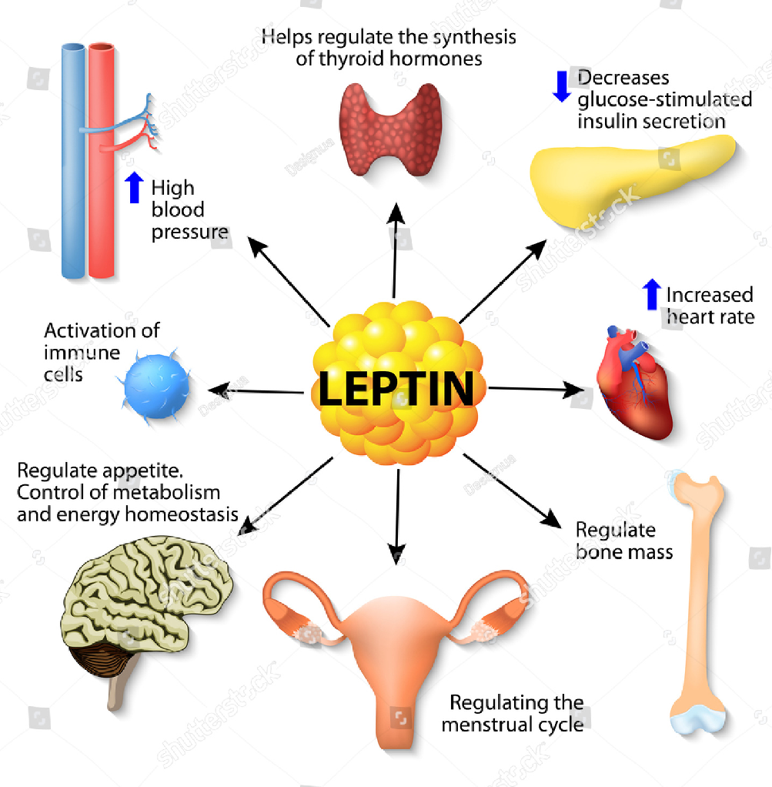

Leptin, an adipocyte-secreted peptide with action in both the hypothalamus and periphery, has a wide spectrum of endocrine and paracrine functions including energy expenditure, and acts as a major signal to the reproductive system (particularly in relation to sexual maturation in females), modulation of steroid production in the ovaries and adrenal cortex, also has been reported to affect a diverse spectrum of metabolic processes, ranging from the inhibition of insulin secretion by pancreatic ß-cells to the stimulation of sugar transport and platelet aggregation factor in angiogenesis and in the immune system(12, 15).
Communication between the immune and adipose systems is bidirectional, since leptin is involved in the regulation of immune responses. Indeed, it regulates pro-inflammatory immune responses, by upregulating both phagocytosis and the production of pro-inflammatory cytokines. Leptin induction during inflammation appears to participate in the cytokine cascade activated during infection and injury(28). The fall in this hormone level triggers a suppression of the immune system during starvation(25).
In addition to its role in the crosstalk between the immune and adipose systems, leptin plays also a key role in the bi-directional communication between the hypothalamo-pituitary- adrenal axis and the adipose system. Leptin described as a satiety factor it conveys an afferent signal to the CNS about body fat stores(1). As leptin acts in the brain, must cross the blood-brain barrier to act at hypothalamic targets(18). Leptin circulates partially bound to plasma proteins and enters the CNS by diffusion through capillary junctures in the median eminence and by saturable receptor transport in the choroid plexus. In the hypothalamus, leptin binds to receptors that stimulate anorexigenic peptides such as proopiomelanocortin and cocaine- and amphetamine-regulated transcript and inhibit orexigenic peptides, neuropeptide Y and the agouti gene-related protein(17). NPY is a very abundant hypothalamic neurotransmitter, involved in numerous metabolic as well as neuroendocrine regulations. It is a potent stimulator of food intake and it also participates in the central adaptations of the corticotrope, thyrotrope, gonadotrope and somatotrope axes include suppression of GH through stimulation of somatostatin, suppression of gonadotropins, or stimulation of the pituitary–adrenal axis to poor metabolic conditions(29, 30). NPY is increased in the hypothalamus in response to leptin deficiency, and postulated to stimulate feeding and weight gain(25).
There is strong evidence showing that the dominant action of leptin is to act as a ‘starvation signal’. Its level declines rapidly during fasting, and triggers a rise in glucocorticoids, and reduction in thyroxine (T4), sex and growth hormones, Moreover, the characteristic decrease in thermogenesis during fasting and post fast hyperphagia is mediated, at least in part, through a decline in leptin. Therefore, leptin deficiency was perceived as a state of unmitigated starvation, leading to compensatory responses, such as hyperphagia, decreased metabolic rate and changes in hormone levels, designed to restore energy balance. Also it contributes to the regulation of body weight. Defects in the leptin signaling pathway result in obesity in animal models(17).
It has been proposed that leptin exerts dual regulation of energy balance, based upon the organism’s state of energy regulation. When energy input is equal to output, leptin concentrations reflect total body fat mass. Alternatively, in conditions of energy disequilibrium, leptin functions as a sensor of energy imbalance, with low concentrations in states of net weight loss and elevated in positive energy balance states(1) .leptin is an important controller of the size of fat stores by inhibiting appetite(31). also this hormone has been demonstrated to have profound effects on skeletal muscle FA metabolism, resulting in an increase in the capacity to oxidize FA and a lowering of triacylglycerol stores(30). Leptin increases lipid oxidation and reduces fat storage, and has increased glucose uptake in skeletal muscle. In liver, leptin has direct effects on gluconeogenesis. These results suggest that leptin, acting in the central nervous system, exerts tissue-specific effects that limit fat tissue mass and lipid accumulation in non-adipose tissues. This would mitigate against the development of obesity and type 2 diabetes(27). Recently, mutations in the human leptin molecule or in the human leptin receptor have been reported as a cause of obesity in children and morbid obesity and hypogonadism in adults(18).
Leptin reduces intracellular lipid levels in skeletal muscle, liver and pancreatic beta cells, and thereby improving insulin sensitivity. In muscle, insulin sensitization is achieved through malonyl CoA inhibition, which increases transport of fatty acids into mitochondria for beta oxidation. These changes are partially mediated by central sympathetic activation of adrenergic receptors(17).
Leptin increases sympathetic nerve activity to kidney, hind limb, and adrenal gland(18). It also promotes proliferation and differentiation of hematopoietic cells, stimulates endothelial cell growth and angiogenesis, and accelerates wound healing(32). Several reports demonstrated an inhibitory effect of leptin on the release of insulin from pancreatic β cells, and another paper reported decreased synergism of insulin-like growth factor I on the follicle-stimulating hormone–induced estradiol synthesis when leptin was present(33).
Leptin has been shown to exert direct effects on peripheral endocrine tissues like the adrenal gland or ovary and pancreas (29). Adrenal glucocorticoid hormones are key regulators of several metabolic pathways, under normal conditions and during the response to stressful stimuli. At low concentrations, corticosterone (or cortisol) is anabolic, stimulating feeding and promoting normal fat and protein storage. Glucocorticoids seem to participate in excessive fat storage, as well as in insulin resistance (33). Since leptin participates in the regulation of metabolism and food intake, at least partially, by modulating the expression of the hypothalamic orexigenic peptide neuropeptide Y, therefore changes in the nutritional or metabolic status of the organism, as reflected by changes in circulating leptin levels, can ultimately modulate the production of cortisol, a hormone with numerous metabolic functions. These effects are mediated, in part, by the lowering of ACTH secretion induced by leptin. reported that leptin can have a direct effect in human and rat adrenal glands to decrease cortisol secretion in a dose-dependent manner, adding to the evidence that circulating leptin plays a role in modulating the activity of the HPA axis in the human And inverse relationship between circulating leptin levels and the activity of the HPA axis has already been reported in the human. Results strongly suggest that the direct effects of leptin on the adrenal are involving the long isoform of the leptin receptor, OB-Rb (33).Therefore high-dose exogenous glucocorticoids increase circulating leptin concentrations in humans. Conversely, leptin has inhibitory effects on the HPA axis, both at the hypothalamic and adrenal levels (34). Perhaps in consequence, leptin and cortisol display an inverse circadian rhythm. As the low leptin concentrations seen in starvation lead to increased HPA axis activity, serving to increase gluconeogenesis and glycogenolysis and ensuring substrate release for fuel metabolism (34).
When fat stores reach the critical point, there is increased release of leptin from adipocytes into the bloodstream. Leptin then acts on hypothalamic cells to stimulate release of LH and LHRH, thereby triggering gonadotropin release. The subsequent release of FSH and LH stimulates gonadal steroid secretion, leading to development of the reproductive tract and induction of puberty (32). Although the adrenal gland and gonads serve as the primary source of circulating steroid hormones, adipose tissue expresses a full arsenal of enzymes for activation, interconversion, and inactivation of steroid hormones (29). Leptin has been shown to modulate GnRH pulse frequency in vitro. It does not act directly on GnRH neurons, but rather via indirect mechanisms through interneurons secreting hypothalamic neuropeptides, such as neuropeptide Y, galanin like protein, melanocyte stimulating hormone (MSH), and endogenous opioids(1). During fasting, the leptin signal is removed and LH pulsatility and reproductive function decline quite rapidly (22). Leptin provides a necessary input of adequacy of energy stores to the brain, thus authorizing but not initiating puberty. Nutritional status is an important regulator of reproductive health. Reproductive potential is appropriately reduced in the setting of undernutrition. The hypothalamic–pituitary axis in men may be more sensitive to the effects of starvation than that in women. Mean LH and FSH decrease within 48 hours of fasting in men. The GnRH pulse generator in men may be more sensitive to the effects of fasting because of the sensitizing effects of gonadal steroids. Older men, whose sex steroid levels have declined with age, do not show the same fasting induced changes in LH pulsatility that are seen in younger men(1). Critical body fat mass is necessary for normal pubertal progression. Overall, the relationship between obesity and timing of puberty appears to differ by the manner in which markers of puberty are defined and documented. There also appear to be differences among different populations (1).
In humans, leptin levels are markedly elevated in obesity and pregnancy. Similar to rodents, deficiencies of leptin or leptin receptor, though rare, are characterized by early-onset obesity and variable degrees of hypogonadotropic hypogonadism (1). Circulating leptin levels exhibit a progressive rise during puberty, suggesting its participation to this phenomenon. Also, the capacity for human plasma to bind leptin was found to drop significantly between the pre-pubertal stage and the beginning of puberty, thus probably increasing leptin bioactivity (30).
In the absence of a deficiency, serum leptin increases during childhood, with the highest concentrations in children who gain the most weight; higher serum leptin concentrations are associated with an earlier menarche (1).
Leptin has numerous effects on peripheral components of the reproductive system. On the gonadal level, leptin has been found in ovarian follicular fluid and a leptin receptor has been localized to the human granulosa, theca, and Leydig cells (1). In humans, leptin may interrupt normal oocyte maturation and has been correlated with poor implantation potential (1).
The predominant effect of leptin’s action on the HPG axis has been hypothesized to be dependent upon its concentration, whereby low leptin exerts a negative influence centrally and elevated leptin yields a negative effect peripherally at the gonadal or embryo level(1).
- Leptin and hormonal secretion

- Leptin and cortisol
Glucorticoids appear to play an important role in the physiological regulation of leptin. Cortisol has been shown to stimulate leptin production in vitro and in vivo. Isolated adipocytes showed a clear stimulatory effect of glucocorticoids on leptin synthesis and secretion. It was suggested that chronic hypersecretion of cortisol could be the cause of inducing not only hyperleptinaemia but also leptin resistance in some groups of obese humans(30).
- Leptin and insulin
Insulin appears to be involved in the regulation of leptin mRNA expression. It has been demonstrated that leptin production occurs after increases in insulin in response to feeding, and that a decrease in leptin concentrations follows insulin declines during fasting(30).
- Leptin and growth hormone
Growth hormone appears to have a negative feedback loop with leptin. As leptin stimulates the production of growth hormone from the pituitary by inhibiting hypothalamic somatostatin production and stimulating the production of growth hormone releasing hormone. leptin appears to be a signal of nutritional status that helps to regulate the pulsatile secretion of growth hormone(30).

- Leptin and other hormones
A number of negative feedback loops appears to exist between leptin and other hormones. Leptin was purported to promote the production of T3, whereas high T3 levels have been shown to reduce circulating leptin(30).
Catecholamines play a role in the regulation of leptin production. Leptin receptors have been found in the adrenal medulla and leptin was shown to strongly stimulate the synthesis and release of epinephrine and norepinephrine from cultured chromatic cells(30).
Strong correlations exist between plasma concentrations of some of the sex hormones and leptin: estrogen is positively correlated, while testosterone is negatively correlated with leptin(30).

Exercise and Endocrine system

  - Stress and stress system
Stress is defined as a reaction to various real or perceived stimuli that threaten to disrupt the homeostatic state of the organism. The stress system coordinates the adaptive responses of the organism to stressors of any kind. The adaptive stress response is characterized by both behavioral and physical changes. The former include increased arousal and alertness, heightened attention, and suppression of sexual and feeding behaviors. The latter lead to redirection of energy, oxygen and nutrients, to the stressed body site and the central nervous system (CNS), where they are needed most(26).The main components of the stress system are the CRH and locus ceruleus–norepinephrine (LC/NE)-autonomic systems and their peripheral effectors, the pituitary–adrenal axis, and the limbs of the autonomic system. Activation of the stress system leads to behavioral and peripheral changes that improve the ability of the organism to adjust homeostasis and increase its chances for survival. overall under threat, the human body elicits a set of neuroendocrine responses that enable the organism to cope with the demands of the homeostatic challenge, The concerted effect of the neuroendocrine responses to stress is the mobilization of lipids from adipose tissue and glucose from the hepatic glycogen stores, which, together with the development of a state of insulin resistance in skeletal muscles, will ensure adequate energy supply to the brain. This facilitates the cognitive and physical adaptation, that is, “fight or flight” response that is crucial for the survival of the individual. This adaptive response to challenge constitutes a controlled deviation from homeostasis that has been termed allostasis meaning “maintaining stability through change (54)(34).

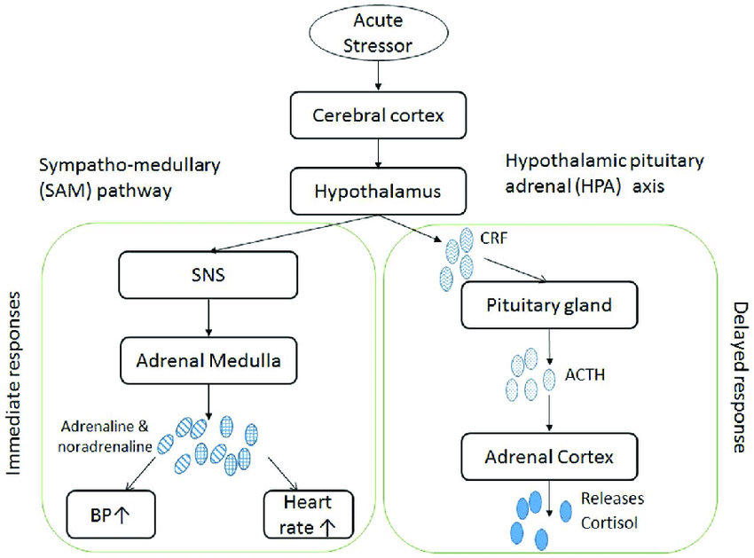

The autonomic nervous system provides a rapidly responding mechanism to control a wide range of functions. Cardiovascular, respiratory, gastrointestinal, renal, endocrine and other systems are regulated by the sympathetic nervous system or the parasympathetic system, or both. Interestingly, the parasympathetic system may assist sympathetic functions by withdrawing and can antagonize them by increasing its activity (54). In addition to acetylcholine, norepinephrine, and epinephrine, both the sympathetic and the parasympathetic divisions of the autonomic nervous system secrete a variety of neuropeptides, such as NPY, somatostatin, galanin, enkephalin, and neurotensin, as well as ATP and nitric oxide (NO). The particular combination of these substances in the neurons of the ANS during the stress response is strongly affected by the CNS and the interaction with the HPA axis(26).
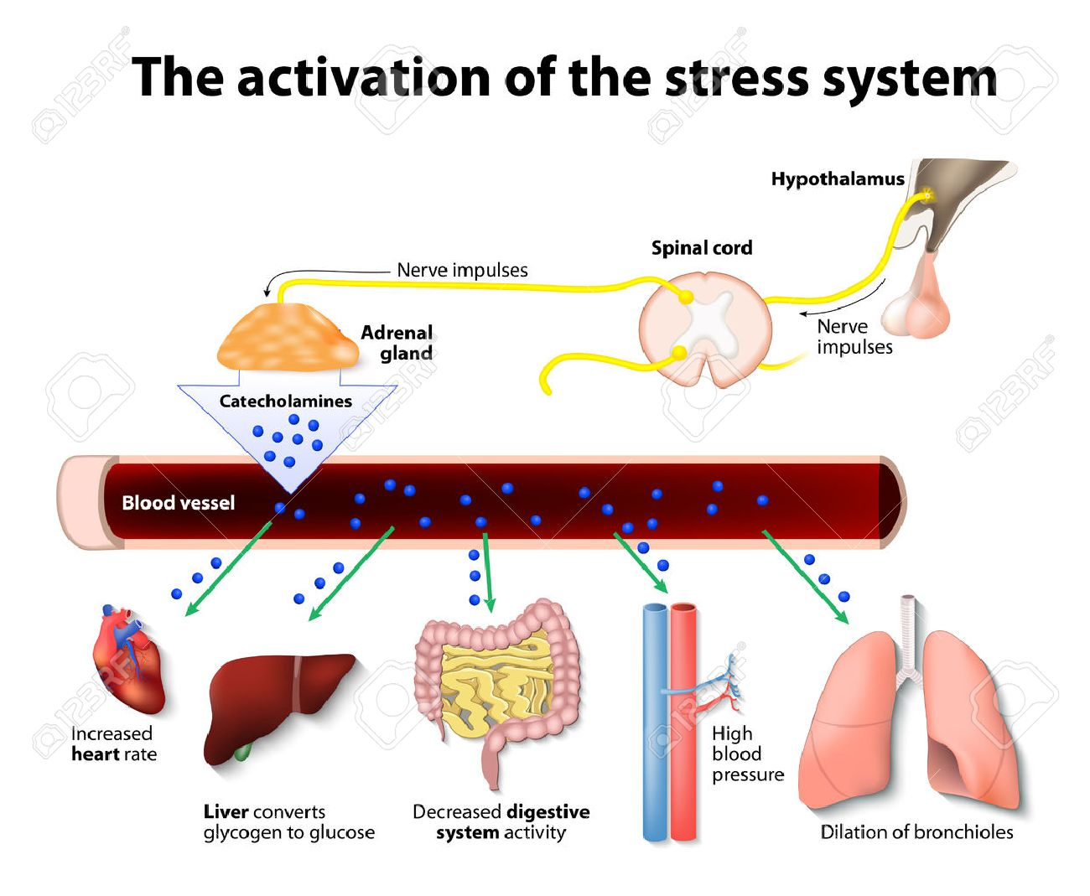

  - Physical exercise as a stressor
Physical Exercise: Planned, structured, and repetitive bodily movement done to improve or maintain one or more components of physical fitness(35). Exercise is an activity that is known to provoke large and diverse stress responses within the neuroendocrine system. However, chronic exercise training is also known to cause abatement in the stress responses of the neuroendocrine system to certain forms of stress. The primary physiological factor that seems to determine the neuroendocrine stress response to a single acute session of exercise is the volume of exposure, where volume is comprised of the intensity and/or duration of the exercise session. Studies suggest that the neuroendocrine stress response to an acute exercise session appears very transient in nature, and during the recovery from exercise, the hormonal levels return to baseline or slightly below basal values relatively rapidly. Hackney and associates have demonstrated this latter point in finding that, typically, prolonged endocrine disturbances only accompany extremely stressful exercise (intensive training or overreaching training) or excessively prolonged exercise (hours to days) in normal healthy adults(36).
Moderate exercise training, combined with a balanced diet, contributes to a healthy lifestyle. The practice of regular exercise for 6 months was shown to be sufficient to improve health outcomes, quality of life, functional capacity and mood states. The beneficial impact of moderate exercise training on patients with cancer, cardiovascular, and endocrine diseases is also well documented. Exercise training alters several physiological processes, including energy metabolism, bone density, muscle metabolism, liver metabolism, and myocardial remodeling, and also modifies electrocardiogram profile. In what concerns the male reproductive system, for instance, Regular moderate exercise training prevents overweight and underweight (common factors of subfertility) and regulates hormone levels. In fact, men who perform regular moderate exercise training scored higher in almost all sperm parameters. Endurance exercise frequently leads to semen deterioration, with men presenting decreased spermatozoa concentration, altered motility, and abnormal morphology. Moreover, endurance exercise disturbs the HPG axis, causing a decrease in the circulating testosterone levels (37).

  - Table. Categorization and definition of exercise intensive and exercise-type(38)
Category term | Relative intensity  (%VO2max) | Energy pathway  predominating | Typical duration | Other  terminology
Light or Easy Exercise | <35% | Aerobic | >30 min | Submaximal
Moderate Exercise | >35% <70% | Aerobic | >30 min <180 min | Submaximal
Heavy Exercise | >70% | Aerobic – Anaerobic | <120 min | Submaximal
Maximal Exercise | ~100% | Aerobic – Anaerobic | <15 min | Maximal or Max
Supra-Maximal Exercise | >100% | Anaerobic | <1 min | Sprints, Power

With respect to the neuroendocrine system, exercise leads to changes in the concentration of many hormones from resting levels, but there are many modifying factors that can influence the neuroendocrine stress response to exercise(36).
  - Table. Major stress-related hormones typically affected substantially by an acute exercise(36)
Adrenocorticotropic hormone | β-endorphin
Corticotropin-releasing hormone | Brain natriuretic peptide
Testosterone | Atrial natriuretic peptide
Cortisol | Cytokines
Growth hormone | Dynorphins
Epinephrine | Enkephalins
Norepinephrine | Renin–angiotensin–aldosterone
Prolactin | Arginine vasopressin

  - Factors that can influence the neuroendocrine system response to an acute exercise session:
- Environmental conditions – heat and cold exposure beyond normal limits can augment the stress hormone responses to exercise
- Age – younger individuals tend to have augmented stress hormone responses to Exercise than older, mature individuals
- Gender – menstrual cycle fluctuations in sex steroid hormones can interact and Affect the stress hormonal response during exercise
- Nutrition – the timing of a meal and its macronutrient content can alter the magnitude and degree of stress hormone response to exercise
- Circadian rhythms – many of the hypothalamic–pituitary–adrenal axis hormones display such rhythms and the exercise response can be influenced by the level of
- Rhythmicity
- Genetics – many individuals display some degree of interindividual variation in how they respond to exercise, which has been attributed to genetic variation(36).

  - Some key points about exercise and endocrine response:

- Acute exercise is a powerful activator of the neuroendocrine system (a stressor), provided that the exercise is of sufficient intensity and/or duration.
- The neuroendocrine stress response to exercise appears to be directly proportional to the volume of exercise exposure.
- These hormonal results of acute exercise (low-to moderate intensity) in adults are typically transient in nature and do not last for longer than a few minutes to hours into recovery.
- The stress response to exercise in adults can be heightened when the exercise is performed in competitive situations.
- Adaptations in the neuroendocrine system with chronic exposure to exercise training results in a reduction in hormonal stress response to submaximal exercise and, in some cases, reduced basal hormone levels in adults.
- This abatement of the hormonal stress response associated with exercise training has potential health implications for dealing with chronic stress-related problems, but more research is necessary in this area.
- In adults, excessive exercise training can push the neuroendocrine exercise stress response to become inappropriate, resulting in the potential development of the overtraining syndrome(36).

  - Effect of Exercise on Leptin
Exercise is known to effectively reduce obesity (fat mass), thus, if leptin levels are affected, this may provide some explanation of how exercise affects obesity; exercise (specifically, caloric expenditure leading to energy imbalance) may lead to reproductive dysfunction, and because leptin is associated with reproductive function, exercise-induced alterations in leptin may elucidate the mechanisms explaining effects of exercise on reproduction, such as the condition of exercise-induced amenorrhea; and exercise alters concentrations of certain hormones that may alter leptin concentrations, including insulin, cortisol, catecholamines, estrogen, testosterone, dehydroepiandrosterone DHEA, and growth hormone. Exercise training-induced reductions in leptin levels have been attributed to alterations in energy balance, and glucoregulatory factors including improvements in insulin sensitivity, lipid metabolism, and unknown factors. Despite numerous studies and different protocols, mechanisms responsible for leptin regulation remain to be determined. Hormone replacement does not seem to affect leptin adaptations to training.(19).
Several groups have tested the hypothesis that increasing the energy expenditure via exercise will lead to a decrease in plasma leptin, but the results have been equivocal. In the majority of these investigations, plasma leptin was unchanged immediately following either a single exercise session consisting of a 10-minute maximal exercise test, 2- to 2.5-hour treadmill run at 70% maximal O2 consumption (VO2max), 1-hour cycling test at 50% VO2max, 2-hour cycling test at 75% ~/O2max, or a 3-hour run. They suggested that the lack of change in circulating leptin immediately following shorter-term exercise does not preclude the possibility of a delayed effect that may be manifested following exercise. The delay may correspond to the time required to observe a decrease in plasma leptin after a decrease in leptin gene expression in the adipocyte or the energy balance of the subjects prior to exercise. Consistent with this hypothesis, Tuominen et aP measured plasma leptin at a single time point, 44 hours following a 2-hour treadmill exercise session at 70% VO2max and observed a 34% decrease. These findings indicate that the leptin concentration may change in concert with alterations in fuel homeostasis during recovery from increased energy expenditure. Hence, in the absence of changes in energy intake and apparent changes in body fat mass, we maintain that increased energy expenditure caused by exercise was the major reason for the decrease in the leptin concentration observed during recovery(22).
These data suggest that exercise training does not independently regulate fasting plasma leptin. The current finding imply that the exercise-induced negative energy balance that produces a loss of fat mass is the primary factor in controlling the fasting plasma leptin concentration with exercise training(39).
Leptin concentrations returned, or largely returned, to preexercise levels with short periods of rest and refeeding, which did not allow sufficient time to restore the adiposity of the subjects. the magnitude of the decrease in leptin concentrations with exercise was much greater than the possible loss in adipose tissue with exercise(40).
Long-term changes in lifestyle consisting of decreased intake of dietary fat and increased physical activity reduced plasma leptin concentrations in humans beyond the effect expected due to changes in fat mass. After dietary intervention, leptin, BMI, and fat mass were reduced, and change in the plasma leptin concentration correlated with change in BMI. Leptin concentrations do not change after normal meal consumption, but dietary changes over a period of 1 year may modify plasma leptin concentrations and energy balance. However, because there are large variations in leptin concentrations among individuals with similar body compositions, it is likely that factors other than adipose mass influence plasma leptin concentrations. This may suggest that increased physical activity overrides the correlation between the plasma leptin concentration and dietary fat intake. Physical activity may reduce leptin messenger RNA expression in rats and lower the abdominal tissue leptin production rate in humans(41).
Lifestyle changes improve carbohydrate metabolism, reduce insulin resistance, and reduce blood pressure in persons with hypertension. Hypothesized that changes in energy intake or expenditure may be detected by the adipocyte and thus influence synthesis of leptin via insulin, corticoids, and epinephrine. A training program that improves insulin sensitivity could alter leptin concentrations independently of adipose tissue mass. The combined diet and exercise intervention reduced insulin resistance. Observed a strong correlation between change in the plasma leptin concentration and changes in insulin and glucose(41). Leptin levels of those who exercised regularly were found lower than the levels in healthy males. Although the increase in serum leptin levels is in direct proportion with BMI in general, the major determinant of serum leptin level is the body fat rate. As regular exercising reduces body fat rate, it also reduces serum leptin levels(42).
    - Leptin responses and adaptations to acute and chronic exercise
Acute and chronic exercises affect body composition, carbohydrate and lipid metabolism. It seems that leptin concentration is not modified after short-term exercise (<60 min) or exercise that generates an energy expenditure lower than 800 kcal. Leptin levels decrease after long-term exercise (>60 min) stimulating FFA release, or after exercise that generates energy expenditure higher than 800 kcal(27). Energy expenditures of either 800 or 1,500 kcal did not change plasma leptin immediately postexercise, but had a delayed depressive effect on plasma leptin in the period between 24 and 48 hours postexercise(22).
There was a decline in leptin concentrations in trained rowers immediately after and 30 min after maximal rowing exercise (30 min). Thus, leptin was sensitive to short-term intensive exercise when all major muscles were involved. Resistance exercise protocols did not result in serum leptin changes when sampled immediately or after 30 min postexercise. These observations underline the importance of using a resting session when evaluating the effect of exercise on leptin concentrations to control for fasting- and/or circadian rhythm-induced leptin reductions. Short supramaximal exercise performed by physically active males and females did not modify plasma leptin and insulin concentrations but increased cortisol concentrations. Under these conditions, leptin production seemed insensitive to exercise. Prolonged endurance exercise involving high energy expenditure (over 1400 kcal) ( alpine skiing and ultramarathon race) induced a marked reduction in circulating serum leptin levels(27).
Thus, it appears that lowered leptin concentrations were observed after long-term exercise (>60 min) that stimulates FFA release, or after exercise that generates an energy expenditure higher than 800 kcal. These decreases could be contributed to by the circadian rhythm of leptin. A role of FFA levels via increased lipolysis could also be suggested. Therefore, it appears that leptin concentrations were not modified after short-term exercises (< 60 min) or exercises that generated an energy expenditure lower than 800 kcal(27).
Long-term (≥60 min) exercise effects on leptin, a reduction in leptin concentrations reported from 1 to 2 hour of running or cycling has been attributed to diurnal reduction in circulating leptin, independent of exercise. Very long bouts of exercise are more likely to reduce leptin levels, which is probably due to disruption of energy balance. Exercise that produces a sufficient energy imbalance (kilocalorie intake versus kilocalorie expenditure) suppresses 24-hour mean and amplitude of the diurnal rhythm of leptin. Suppression of leptin concentrations may be counterbalanced by feeding. This appears to explain consistent reductions reported in leptin concentration after extreme bouts of exercise such as marathons or ultramarathons(19).
- Long-term training (>12 weeks)
A 12-week aerobic training programme significantly decreased leptin level and these decreases in leptin concentrations were associated with fat mass loss, so chronic mild aerobic exercise training significantly lowers serum leptin concentrations and thus may improve the leptin resistance observed in overweight men(27).
- Short-term training (<12 weeks)
In spite of significant reductions in fat mass and serum-free testosterone, serum leptin concentrations were not significantly altered by 6 weeks’ strength training performed by 12 physical education students. This stability of leptin concentrations occurred with significant changes in body fat percentages, in serum testosterone and in serum cortisol. It is concluded that the change in blood leptin level is independent of the changes in cortisol, testosterone and fat percentage in highly trained male athletes in the state of overtraining syndrome(27). plasma leptin is unaltered by exercise or small changes in energy balance over short periods of time(19).
Thus, short-term training (< 12 weeks) and long-term training (>12 weeks) have disparate effects concerning leptin concentration. Exercise training protocols that result in reduced fat mass are generally accompanied by lower leptin concentrations. Reductions in leptin levels have also been attributed to alterations in energy balance, insulin sensitivity and lipid metabolism(27).
The data from investigations examining single exercise bouts suggest that serum leptin concentrations are unaltered by short duration (41 minutes or less), non-exhaustive Exercise, but may be affected by short duration, exhaustive exercise. More convincingly, studies investigating long duration exercise bouts indicate that serum leptin concentrations are reduced with exercise durations ranging from one to multiple hours. These findings raise speculation that exercise-associated reductions in leptin may be due to alterations in nutrient availability or nutrient flux at the level of the adipocytes, the primary site of leptin production and secretion(23).
Plasma leptin concentrations are associated with fitness level; however, these relationships are not independent of body fat mass. It appears that circulating Leptin levels are only decreased by bouts of exercise with considerably high intensity and long duration(23).
In addition, leptin concentrations are reduced 48 hour after long-term aerobic exercise and long-term resistance exercise is associated with delayed leptin reduction 9 hr postexercise. Training studies have documented that short-term exercise training (≤12 weeks) does not affect leptin levels, with the exception of patients with type 2 diabetes. Hormone replacement does not seem to affect leptin adaptations to training. Studies that controlled for fasting demonstrated that meals and insulin acutely affect leptin concentrations. Other hormones associated with the regulation of leptin that are altered by exercise include glucocorticoids, growth hormone, and catecholamines. Growth hormone and cortisol have been shown to promote leptin production, whereas catecholamines inhibit leptin production(19).
    - Mediators of Plasma Leptin Concentration Following Exercise
Immediately following exercise, plasma insulin was depressed and then increased to the control value during the first 24 hours of recovery. This transient decline in the insulin level preceded any significant decline in the plasma leptin concentration. Since elevated insulin levels have been shown to stimulate the plasma leptin concentration, a reduction in insulin levels during exercise or recovery from exercise might signal a temporary reduction in the synthesis/release of leptin from the adipocyte, resulting in lower plasma levels. However, it should be noted that the acute stimulatory effects of insulin on leptin are somewhat controversial. Other studies indicate that the effects of insulin on leptin are observed only after 6 to 24 hours of hyperinsulinema and may be concomitant with changes in fat mass(22).
Adipocyte leptin synthesis may have been suppressed through increases in adrenal or sympathetic nerve-derived norepinephrine. Endurance exercise results in an increase of norepinephrine and epinephrine release, and residual hormone/neurotransmitter may slowly decrease during recovery. Leptin synthesis has also been shown to be diminished by increased levels of testosterone. During prolonged submaximal exercise, circulating levels of testosterone have been shown to increase. Hence, it is also possible that exercise-induced increases in testosterone may have suppressed the leptin concentration following exercise(22).

    - Role for Leptin during exercise recovery
A decrease in leptin may facilitate the restoration of body fuel homeostasis during recovery from periods of increased energy expenditure. Low leptin levels after exercise may stimulate food intake, as well as repletion of energy stores in muscle fibers recruited during exercise. Leptin receptors have been found to be expressed in muscle tissue, and elevated leptin levels shift muscle metabolism away from free fatty acid esterification toward oxidation. Hence, lower leptin concentrations may permit a greater level of free fatty acid storage as triglyceride(22).
Leptin has been demonstrated to induce insulin resistance also reported that insulin resistance is independently associated with an elevated plasma leptin concentration in males. It is thus conceivable that the reduction in plasma leptin with exercise training may improve insulin action(39).
  - Effect of Exercise on Testosterone

    - Basic testosterone physiology and endocrinology
Testosterone is structurally a steroid hormone. Its proper systematic chemical name is 17β-hydroxy-4-androsten-3-one. Other principal steroids substances in the body (hormonal or otherwise) are cholesterol, bile acids, Vitamin D, and hormones of the adrenal glands and gonads. The majority of circulating testosterone in men comes from production within the Leydig cells of the testis (~95%). Although within the male, the adrenal gland also produces small amounts of the hormone. Regulation of testicular production occurs via a negative feedback regulatory loop system involving the anterior pituitary, hypothalamus, and testicles, and is referred to as the hypothalamic-pituitary testicular axis (also referred to as the hypothalamic-pituitary-gonadal axis). Approximately 98% of the circulating testosterone is transported bound to various carrier-proteins (sometimes referred to as binding proteins). Sex hormone-binding globulin (SHBG) is the principal carrier protein; however other plasma proteins can also bind and carry testosterone to a lesser degree (albumin and cortisol-binding globulin). The remaining unbound circulating testosterone is referred to as free testosterone. This free testosterone is considered the biologically active form of the hormone, as this is the portion of the hormone that can interact with target tissue receptors. The circulating bound and free testosterone components are collectively referred to as total testosterone(38). Testosterone production in men approximates 5 mg per day and the secretion occurs in an irregular pulsatile manner. There is a diurnal pattern: the peak level is in the early morning, and the nadir is in the evening(43). With aging, serum T concentrations progressively decline, by about 1% per year, mainly due to a decline in the capacity of aging Leydig cells to produce T in response to LH stimulation (44).
    - Physiological roles
Testosterone is a key hormone in the male and has a multitude of major physiological roles. These physiological roles can be categorized into those having: (i) Androgenic effects – which are related to reproductive function and the development of a male's secondary sex characteristics; (ii) Anabolic effects – which involved in muscle tissue growth, recovery and remodeling, and performance enhancement(38). Testosterone stimulates the development of bone and other connective tissues and neural tissue (testosterone can interact with receptors on neurons and increase the amount of neurotransmitters released, regenerate nerves, and increase cell body size and dendrite length/diameter) and induces erythropoiesis(44).
    - Metabolic clearance rate of T
The main component of MCRT is the extensive enzymatic conversions of T in the liver and elimination of T metabolites, such as androsterone and etiocholanolone, by the kidney. Thus, urinary androsterone and etiocholanolone can be considered the final end products in the T degradation pathway. The MCRT processes include also, to a smaller extent, aromatization of T to estradiol and interaction of T with target tissues via androgen receptors(45). Individual metabolic clearance rates (MCR) of testosterone vary, but are estimated to be approximately 100 liters per day(38). Half of the testosterone produced is cleared through the liver and the remainder is cleared through extrahepatic metabolism(46).
    - Factors affecting circulating T level
Circulating production stimulators (lutropin), testicle lutropin-receptor numbers, and substrate availability for synthesis affect this rate. Research suggests that lutropin and testosterone levels are directly related to one another. This is demonstrated by the fact that in the presence of elevated lutropin there is a reduced testosterone production if a decreased number of testicular lutropin receptors exist. Hyperprolactinemia and hypercortisolemia can also produce lowered circulating testosterone levels. The exact mechanism for this lowering of testosterone is uncertain, but may be due to interference with Leydig cell receptors and/or direct inhibition of the steroidogenic synthesis pathway. Any reduction in the availability of steroid hormone precursors (cholesterol or pregnenolone) can produce a lower rate of testosterone synthesis. Anything that influences vascular tone can also affect the rate of testosterone secretion(38).
In men, levels of testosterone gradually decrease from age 30 and low T concentrations are associated with low skeletal muscle mass. The age-related loss of skeletal muscle mass and function represents increasing risks for physical disability and metabolic disorders in older persons. Resistance training (RT) is one of the most promising interventions to counteract the age-related muscle decline. Acute resistance exercise-induced responses in serum T may change during long-term RT, and the changes could be related to size changes of the trained muscles. Acute changes in serum T may have a role in the RT-induced adaptations of skeletal muscles and that T metabolism may change during long-term RT, possibly by transient exercise-induced alterations in T metabolism(45).
many factors may influence the acute HPT axis response to acute physical exercise: (a) exercise characteristics (type, intensity and duration); (b) individual factors (genetic, training, nutrition, hydration, body composition, psychological stress, social anxiety, motivation, endocrine diseases); (c) the associated stress hormones responses to exercise ( catecholamines, GH, cortisol); and (d) the assumption of prohibited (androgenic anabolic steroids, glucocorticoids) and not prohibited substances (non-steroidal anti-inflammatory drugs, phosphodiesterase inhibitors, amino acids)(47).
- Prolonged strenuous physical activity
Prolonged strenuous physical exertion reduces serum LH and testosterone levels, apparently by suppressing gonadotropin-releasing hormone secretion. Research does show the existence of a select group of men who through their exposure to chronic endurance exercise training have developed low basal, resting testosterone levels. The majority of these men display clinically “normal” levels of the testosterone hormone, but the levels are at the very low end of normal and border on a sub-clinical status. The consequences of these hormonal changes may exhibit as spermatogenesis and male infertility problems in these men(38). Strenuous long-term treadmill exercise caused a significant decrease in plasma LH, FSH, and T concentrations. Gebreegziabher et al. investigated the influence of cycling on sperm characteristics, they concluded that endurance cycling appears to be associated with a significant alteration in sperm morphology. In another study, gonadal hormones and semen quality were evaluated in male runners. In this study the volume of training was significantly correlated with sperm motility, density, and number of round cells. Lower basal levels of T or FT have also been reported in endurance-trained individuals in previous studies (38).
Long term exercise associated suppression of serum testosterone may result from decreased production rates, decreased protein binding, or increased clearance. The decreased production rates of serum T may is associated with suppressed endogenous GnRH stimulation of gonadotropin release during exercise, and decreased testicular capacity to secrete T during recovery period(46).
Several studies, which have used single blood samples, have found lower testosterone levels in men who had been involved with exercise training in their sport for 1 to 15 years, subjects of these studies have been almost exclusively distance runners. Testosterone levels of them were only 50–85% of the levels of matched sedentary control male subjects in these studies(38).
These men have the following common characteristics:
  - They have low resting basal testosterone levels, typically 50–75% that of normal, Healthy, age-matched sedentary men.
  - Their low testosterone levels do not appear to be a transient phenomenon related to the acute stress-strain of exercise.

  - They typically have a history of early involvement in organized sport and exercise training. This has resulted in many years of almost daily exposure physical activity in these men.
  - The type of exercise training history most frequently seen in these men is prolonged, endurance-based activities such as: distance running (long track [10 km] or road events [marathons]), cycling, race walking, or the triathlon(38).
Studies also exist in which basal blood samples have been collected over weeks or months while exposing subjects to endurance training regimens. The findings from such studies have been inconsistent. Several studies reveal significant reductions (decreases of 20–40% from pre-training levels) in basal testosterone following 1 to 6 months of intensive training. Other studies, however, report no significant change in basal testosterone after 2 to 9 months of training. Differences in the initial training status of the subjects, or the training dosage administered within these studies may perhaps account for the discrepancy in findings(38).
Contrary to the above discussion, there could be beneficial physiological effects from the lowered testosterone. For example, some research indicates that lowering testosterone may have cardiovascular protective effects and decrease the risk of coronary heart disease. Investigators in Germany have provided strong evidence supporting this claim(38).
- Short-term high-intensity exercise
Short-term high-intensity exercise increases circulating testosterone levels and produces variable effects on LH concentrations, The mechanisms responsible for the increase in serum testosterone levels during short-term exercise are controversial, and may include, water redistribution/sweating-related modifications of plasma volume, testicular blood flow and/or of testosterone metabolic clearance rate ( for decreased hepatic blood flow and/or modified serum albumin and SHBG concentrations), and/or increased secretory capacity of the Leydig cells—due to exercise related LH-dependent or -independent mechanisms (,catecholamines, lactate, and so forth),hemoconcentration, and/or increased testosterone production due to stimulation by factors other than LH(47, 48).
LH has been reported to be unchanged, increased or, rarely, decreased after sub-maximal and maximal acute exercise, independently from testosterone modifications(47). Although plasma growth hormone, vasopressin, adrenocorticotropin, cortisol, and prolactin levels increase with exercise, these hormones are not known to substantially increase testosterone production. An increase in catecholamine levels during exercise is also well documented(48).
The sympathetic nervous system can also influence testosterone production through direct neural pathways and perhaps circulating catecholamines. Short term strenuous activity produces a substantial increase in circulating catecholamines and beta-blockade abolishes the exercise associated serum testosterone increase(49).
Exercise can impact on serum T concentrations by altering MCRT, Since the liver is the major site of testosterone clearance and since hepatic blood flow decreases during exercise, reduced testosterone clearance most likely is responsible for the increase in testosterone during exercise(48), while increases in PRT may be caused by increases in LH pulsatility or production(45).
- Non-physiologic factors affecting circulating hormonal levels
It is important to consider the non-physiological factors that could account for variations in testosterone response among research studies. Examples include blood sampling method, diurnal variations in hormone concentrations, hormone detection methodology and research protocol. The timing and method of blood sampling are issues that must be carefully examined when comparing and evaluating testosterone results of different studies. There is a large daily circadian pattern in blood testosterone levels. A single blood sample could therefore provide an imprecise estimate of the average hormonal level. The use of multiple or serial blood sampling and then pooling these to form an aggregate value would provide a more accurate assessment. The most accurate information is attained by serial blood sampling because it can provide a more detailed timeline of circulating testosterone changes which can be critical to the interpretation of results. The detection methodology used to assay for the hormone must also be considered a source of variability in testosterone results. Radioimmunoassays (RIA) and chemiluminescence assays are the current most popular means of assessing testosterone concentrations in blood samples. Of these two, RIA methods are probably the most prevalent because of financial cost considerations. Psychological stress such as, sleep loss, diet, weight loss, and hereditary ethnicity factors all affect testosterone levels. Finally, there is the issue of exercise in comparing findings across studies, account must be taken of the mode of exercise, the duration of exercise, and the intensity at which the exercise was performed. In addition, one must recognize the degree of prior exercise training of a subject. That is, hormonal responses are known to be different in trained individuals than untrained or moderately trained individuals (38).
2.7 Prolonged exercise and CRH
Prolonged, submaximal exercise is associated with significant rises in peripheral CRH that are not associated with hypoglycemia. The rise in AVP is consistent with the plasma osmolality changes that occur. High-intensity exercise is associated with a further elevation in ACTH, combined with an increase in AVP, which in some subjects is out of proportion to osmolality changes. It is proposed that the mechanism by which activation of the HPA axis occurs during exercise may involve the hypothalamic secretion of both CRH and AVP, with high-intensity exercise favoring AVP release and prolonged-duration exercise favoring CRH release(8).
Exercise of appropriate intensity is a potent stimulus for GH and cortisol secretion. The GH and cortisol responses to exercise are both dependent on the relative exercise workload, but other factors modulate these hormonal responses, including the mode and duration of exercise, anaerobic vs. aerobic exercise, prior meal ingestion, and fitness level of the subject. Underlying pulsatile and circadian/diurnal rhythms of these hormones potentially may modulate the exercise response observed. Some studies have shown Time of day or circadian rhythms has no effect on the magnitude of the GH response to exercise. In contrast, the cortisol response to exercise is modulated by time of day(50).
2.8 Exercise and Cortisol
Cortisol, the main glucocorticoid form in humans, is a catabolic steroid hormone secreted from the adrenal cortex in response to physical and psychological stress. Findings have shown that moderate to high intensity (60%, 80%) exercise will provoke significant increases in circulating cortisol. These increases seem to be brought about by a combination of hemoconcentration and well as enhanced secretion stimuli (ACTH) within the HPA axis. In contrast, low intensity (40%) exercise does not result in significant increases in circulating cortisol levels. In fact, if one considers the resting-control cortisol response, and the plasma volume reduction within this exercise session, then the 40% intensity actually results in a reduction in circulating hormonal levels. The lack of elevation at the low intensity exercise may reflect increased MCR, in particular target tissue uptake of the hormone. (51, 52). The exercise stimulus to increase cortisol levels is due not just to the intensity but also to the duration of exercise (or a combination of both factors interacting). While cortisol increases during exercise, most of the changes and perhaps effects of this hormone occur after exercise during the early recovery. Once released, cortisol is taken up by a variety of tissues throughout the body, such as skeletal muscle, adipose tissue, and the liver. At these different tissues, the presence of cortisol mediates critical physiological processes which aid in exercise capacity and recovery, promoting proteins in the skeletal muscle to be broken down into amino-acids, and triglycerides in adipose tissue to be hydrolyzed into free fatty acids and glycerol. In addition, the presence of very high circulating levels of cortisol may stimulate gluconeogenesis in the liver, providing additional carbohydrate for energy production. The secretion of cortisol is regulated by negative feedback, in which high circulating levels signal the anterior pituitary to decrease ACTH secretion. Conversely, increased levels of ACTH and, or cortisol can signal the hypothalamus to decrease CRH secretion(52). Cortisol secretion is pulsatile. The amplitude and frequency of cortisol secretory pulses are modulated by a circadian rhythm. Circulating cortisol concentrations are maximal in the early morning hours just before awakening as a result of increased cortisol secretory pulse amplitude and frequency. The amplitude of cortisol secretory pulses progressively decreases throughout the day until cortisol concentrations are quite low in the evening. Meals stimulate cortisol release in humans. Exercise performed immediately after food ingestion results in a blunted cortisol response to the exercise stimulus(50).

    - Relationship between cortisol and testosterone
Previous pharmacological and pathological studies have reported negative relationships between circulating testosterone and certain stress hormones (cortisol and prolactin) in humans. They support the idea that cortisol can lead to a physiological reduction of circulating testosterone. The mechanism for this effect has been speculated to be by direct steroidogenesis inhibition at the Leydig cells of the testes and/or central and peripheral disruption of the hypothalamic-pituitary-gonadal regulatory axis, indeed by inhibition of LH and GnRH or inhibition of testicular luteinizing hormone receptors(53).
  - Exercise and Growth hormone
Growth hormone (GH) is secreted by the anterior pituitary in a pulsatile pattern. GH secretion is regulated by two hypothalamic peptides: GH releasing hormone (GHRH), which stimulates GH synthesis and secretion, and somatostatin, which inhibits GH release without affecting GH synthesis. Many of the metabolic effects of GH are mediated by insulin-like growth factor (IGF)-I, which is synthesized in the liver under GH control and exerts a rapid negative feedback on GH release. Human growth hormone (hGH) represents a family of proteins rather than a single hormone and plasma, over 100 forms of GH have been identified in with apparently different physiological functions. In the circulation, the dominant form of GH is a 22kD protein. However, approximately 10% of circulating GH is a 20kD protein and there are also various lower molecular weight fragments of GH. The regulation of energy metabolism by GH is believed to be mediated by direct interaction of GH with the GH receptor (GHR) on target cells. GHRs are found in many tissues throughout the body including kidney, liver, muscle, and adipose (54). hGH is produced throughout life, with its highest values during puberty. hGH has many varied roles throughout life, from growth itself, including the turnover of muscle, bone and collagen, GH acutely stimulates muscle protein synthesis in healthy human adults, and regulates selective aspects of metabolic function ,hGH promotes the release of free fatty acids and glycerol from the adipose tissue, increases circulating free fatty acids and their oxidation in the liver. also hGH generally antagonizes the effects of insulin In the liver by increasing liver glycogen derived from amino acids (55).
GH deficiency in adults with hypothalamic or pituitary disease leads to altered body composition and has been associated with increased risk of premature cardiovascular disease. In addition, GH deficiency is linked to reduced exercise capacity, insulin resistance, dyslipidaemia, vascular dysfunction and reduced left ventricular mass and lower ejection fractions. GH production and release decreases with Age by approximately 14% per decade after the age of 40 years and is decreased in conditions such as obesity. Many physiologic factors alter pulsatile GH secretion, including age, gender, body composition, sleep, nutrition, exercise and serum concentrations of gonadal steroids, insulin and IGFI. the magnitude of GH release is greater in young women than in young men and is reduced by 4–7 fold in older individuals compared with younger individuals (54). In general, hGH secretion follows a circadian rhythm and is secreted in 6–12 discreet pulses per day with the largest pulse being observed around 1 hour after the onset of night-time sleep(55). Food ingestion may account in part for the lower levels of GH secretion during the day; ingestion of high fat meals is known to blunt the GH response to exercise (50).
Exercise is a potent physiological stimulus for growth hormone (GH) secretion, but combination of the intensity, duration, frequency and mode of exercise that determines the exercise-induced growth hormone response (EIGR)(55). Both aerobic and resistance exercise result in significant, acute increases in GH secretion. Since decreased GH secretion in aging and other conditions such as obesity is associated with many detrimental health effects it can be suggested that the use of regular exercise as a stimulus for GH release may have positive effects on health and well-being. Studies have also reported that older individuals have decreased exercise-induced GH release. These decrements in exercise- stimulated GH release may be due to excessive somatostatin (SRIH) release and/or diminished GHRH secretion(54). Several investigations have suggested that Intensity and duration of acute exercise, work output during exercise, muscle mass used during exercise, and training state all influence the GH response to exercise(56). The EIGR is well recognized and although the exact mechanisms remain elusive, a number of candidates have been implicated. These include neural input, direct stimulation by catecholamines, lactate and or nitric oxide, and changes in acid-base balance. Of these, the best candidates appear to be afferent stimulation, nitric oxide and lactate(55).
Some studies have suggested an intensity ‘threshold’ exits for EIGR. Pooled data from 29 studies suggest that the threshold for hGH secretion occurs on average above 40% VO2max. The majority of authors, however, suggest that for a consistent EIGR, an exercise intensity above 60% VO2max is required. It has been suggested that the threshold for the exercise-induced hGH surge is consistent with lactate threshold. The differences in the percentage of VO2max at which the EIGR has been observed to occur may reflect the heterogeneity in the percentage of VO2max at which lactate (anaerobic) threshold generally occurs in any exercising population. According to Wasserman et al., the point at which metabolic acidosis becomes evident can range from 40–80% of VO2max in normal individuals. Accordingly, in hormonal studies in general, and those that examine hGH in particular, it may not be appropriate to use percentage of VO2max as the index of relative exercise intensity. Rather, lactate Threshold itself may be a more appropriate and consistent measure of exercise intensity when associated with the hGH surge. Exercise may also affect hGH release at rest. Weltman et al. showed that exercise training above the lactate threshold amplified the pulsatile release of hGH at rest, while exercise below the lactate threshold didn’t(55).
    - Acute and chronic resistance exercise
Although acute resistance exercise results in increased GH release, the GH response to resistance exercise is influenced by the work-rest intervals, the load and frequency of the resistance exercise that is used. Generally, resistance exercise protocols with high total work and short rest intervals or high repetitions with moderate power (70% or greater), resulted in the greatest GH response. The average peak GH concentration attained during acute aerobic exercise is also between 5–25 µg/L. When extremely high intensity aerobic work (90% maximal oxygen uptake [VO2max]) is employed, mean GH concentrations as high as 50 gg/L have been reported. Thus, the magnitude of the GH response is similar with either acute aerobic or resistance exercise of appropriate intensity and duration. Studies investigating the effect of chronic resistance training on GH release have shown that resting levels of GH are unchanged with resistance training (54).
    - Endurance Training and GH Release
Studies have shown that endurance training reduces the exercise-induced GH release and results in decreased resting hGH, which may be linked to an increased tissue sensitivity to hGH. Endurance is when you gain your slow twitch muscle fibers and strength when you train fast twitch fibers. For example, marathon would be endurance, sprint would be strength (54, 55).
  - Insulin like growth factors
Pituitary, itself inhibiting further release of hGH, whilst the other affects GH releasing. IGFs represent a group of growth factors also called (somatomedins) that are produced by many tissues in the body, but few organs are believed to concentrate IGFs. The liver is thought to be the primary source of circulating insulin like growth factor I (IGF-I), with the serum demonstrating the highest concentrations. IGF-1 released from the liver in response to hGH is involved in two negative feedback loops. One directly affects the somatotrope cells of the anterior hormone and somatostatin release from the hypothalamus to reduce the secretion of hGH. Although most of the anabolic actions of hGH are mediated by the somatomedins (IGFs), some actions are mediated in individual cells by pathways initiated by direct activation by hGH via the GH receptor (55). IGFs are complexed with high affinity binding proteins and six distinct binding proteins have been characterized. Four of these binding proteins are found in the serum. More than 90% are bound in the 150-kDa complex that involves IGF-I or - I I, binding protein 3, and an acid-labile subunit. Binding proteins are differentially regulated and have different functions in various tissues and cells. A primary endocrine stimulus for IGF-I production is growth hormone, which mediates IGF-I synthesis, synthesis of the components of the 150-kDa complex of IGF-I, and binding protein 3. Most of the actions of IGF-I are mediated by the IGF-I receptor(57). IGF-1 concentrations in blood are more stable through the day due to binding to proteins. The slow changes in circulating IGF-1 are consistent with IGF-1 dynamics: only 1% of IGF-1 circulates freely in plasma; the remaining 99% is bound to carrier proteins and the half-life of the predominant protein complex is long (15 h)(58).
GH and IGF-1 axis are involved in the metabolism of carbohydrates, lipids and proteins. The need for energy supply is increased during exercise and is associated with adaptive hormonal changes. GH and IGF-1 contribute toward mobilizing the energetic substratesWhich are required for an acute exercise and are involved in bone and muscle anabolic responses to physical training. GH has direct effects on muscle and also stimulates IGF-1 hepatic production to induce protein synthesis and cell mitosis. GH stimulates IGF-1 secretion from the liver, and peak IGF-1 concentrations in blood have been observed 16–28 h after GH injections in human. The effects of exercise and training on IGF-1 and its binding proteins IGFBP-1 and -3 remain incompletely understood. Some studies have shown acute increases in serum concentrations of IGF-I can occur after brief high-intensity aerobic exercise. However, these acute changes are not related to increases in GH and no consistent rise in circulating IGF-I over 24 h were observed(58).
  - The Overtraining Syndrome
Findings of suppressed reproductive hormones in endurance-trained males have been reported, if they are involved in “overtraining” and, or are developing the “Overtraining Syndrome. The Overtraining Syndrome is a pathological disorder where an athlete experiences consistent and persistent exercise performance incompetence that does not reverse itself after a few days of rest and recovery. This exercise performance impairment can manifest itself within athletic competition as well as during exercise training. Concurrent with the declining physical performance other psycho-physiological consequences manifest that are adverse and negative in nature. In addition to the psycho-physiological alterations one commonly reported endocrine change of overtrained athletes is suppressed circulating levels of testosterone, lutropin, follitropin and inhibin. While these changes appear nearly identical to those reported for exercise-hypogonadal men. The hormone changes found in overtraining athletes appear to be only temporary. That is, reproductive hormonal alterations in exercise hypogonadal Men seem more chronic in nature(38).
The research on over-reaching–overtraining by several investigators suggests that the neuroendocrine stress hormonal response seems to be of two phases: an initial hyperactivity phase, followed by a latter hypoactivity phase. The neuroendocrine hypoactive phase seems to correspond with the overtraining point and/or with the manifestation of the overtraining syndrome. In the latter situations, neuroendocrine function becomes suppressed for certain hypothalamic, pituitary and adrenal cortical hormones (ACTH, luteinizing hormone, follicle-stimulating hormone catecholamines and cortisol). The development of the hypoactivity phase appears to be the more serious outcome as it may require weeks or months for the athlete to recover and regain normal endocrine function (38).

  - Table. Major signs and symptoms of overtraining syndrome
Physiological function | Psychological function
Decreased competitive performance | Increased feelings of depression
Decreased muscular strength | Lethargy
Increased muscular soreness | Emotional abnormalities
Chronic fatigue | Loss of appetite
Reduced tolerance to training overload | Restlessness
Sleep–wake cycle abnormalities | Lack of competitive drive
Gastrointestinal disturbances | Difficulty in concentrating
Reduced sexual drive and libido
Altered heart rate responses
Suppressed immunological function

Many of the overtraining symptoms identified for aerobic exercise, such as alterations in sleep patterns, resting heart rates, mood states, and sympathetic activity, have not been reported for anaerobic overtraining protocols. Furthermore, altering some of the acute training variables for resistance exercise (volume of exercise, rest intervals, and load) results in a variety of different physiological responses. Increased volumes of aerobic exercise and resistance exercise have resulted in decreased concentrations of several hormones at rest(59).
An increasing number of research studies in men indicate exercise training has significant effects upon the major male reproductive hormone, testosterone, and the hypothalamic-pituitary-testicular axis that regulates reproductive hormones. Specifically, findings suggest basal, resting-state testosterone (free and total levels) is significantly and persistently reduced in men involved in chronic endurance exercise training. This condition has been referred to as “exercise-hypogonadism”. The exact physiological mechanism inducing the reduction of testosterone is currently unclear. The potential exists for these reduced testosterone levels within the exercise-hypogonadal male to disrupt and be detrimental to some anabolic or androgenic testosterone-dependent physiological processes. Conversely, the alterations in testosterone levels brought about by endurance training could have cardiovascular protective effects and thus be beneficial to the health of these men(38).
  - Clinical concerns on the adaptive role of HPT axis
The functional balance between HPT and HPA axes adaptation during acute exercise may positively or negatively influence many peripheral tissues and systems (central nervous system, cardiovascular system, cells metabolisms, and so forth). For example, when skeletal muscles are concerned, testosterone stimulates protein synthesis and inhibits protein breakdown and oxidation, by increasing amino-acid uptake and IGF-1 production, inhibiting Total cortisol C signaling and acting synergistically with GH. In the absence of adequate testosterone adaptation, the increased C during heavy exercises may favor muscle mass loss by decreasing protein synthesis (lowered amino acids transport, inhibition of IGF-I) and increasing protein breakdown due to proteolytic activation (ubiquitin–proteasome system, cathepsins, calpains)(47).
Because of the observed increased TT, GH, anabolic/catabolic steroids ratios (TT/C, Dehydroepiandrosterone DHEAS /C) and reduced C, we could further support the concept that short-term sub-maximal endurance exercises should be the first choice for healthy lifestyle, particularly in males before puberty and when a positive anabolic/catabolic status or an anti-stress like effect are requested(47).
  - In summary Methodological and procedural factors that can influence the measurement and assessment of circulating hormone levels in the blood
- Circadian rhythms (time of day of specimen collection)
- Specimen collected (hormone concentrations differ in blood, urine or saliva)
- Specimen collection procedure (catheter or venipuncture for blood)
- Biochemical assay for detection (radioimmunoassay or chemiluminescent)
- Subject dietary practices (consumption of meals prior to specimen collection)
- Environmental factors (heat, humidity, barometric pressure)
- Subject life stressors (relationships, finances and security)


Exercise and reproductive dysfunction

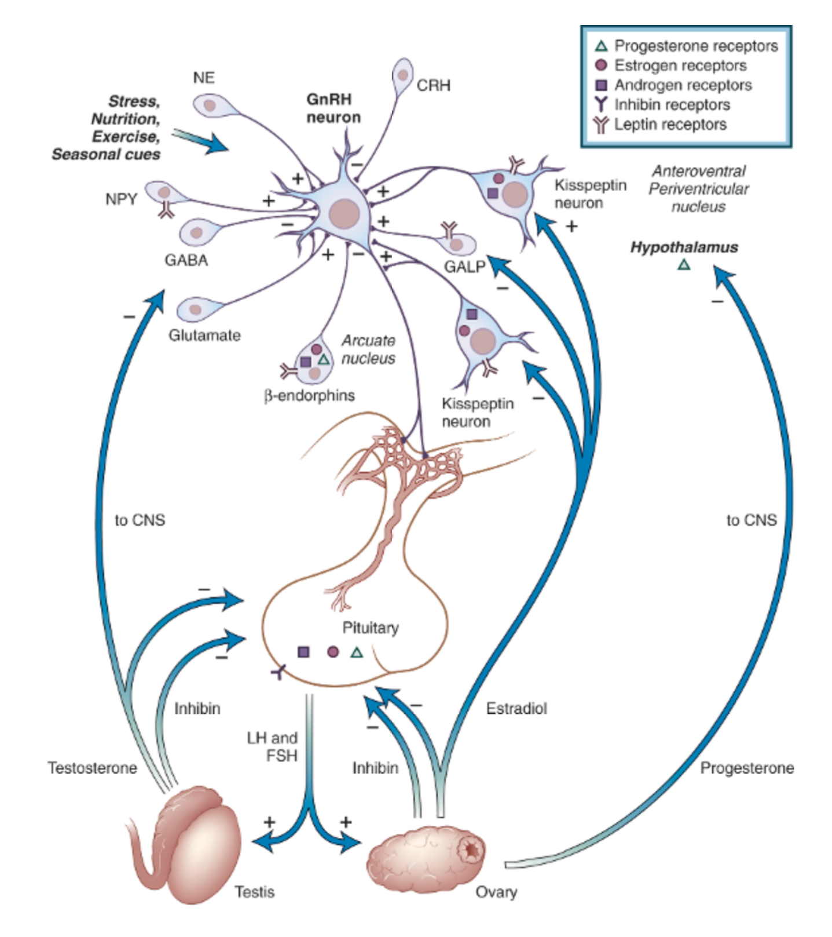
LEPTIN
Adipose cell

THE HYPOTHALAMUS-PITUITARY GONADAL AXIS

  - An overview of hypothalamic-pituitary-gonadal (HPG) axis regulation
Male reproductive hormones consist of hypothalamic decapeptides, GnRH, pituitary gonadotropins, LH and FSH, testicular steroids, testosterone and estradiol (T and E2) (1).
The main functions of the testes are steroid biosynthesis and spermatogenesis. These are controlled by higher structures of the HPG axis operating under a negative feedback system, the major gonadal regulatory hormone being testosterone. GnRH, secreted in pulses by the hypothalamus, stimulates the pituitary gland to secrete the two gonadotropic hormones, LH and FSH. LH stimulates the testis to secrete testosterone, while FSH facilitates sperm production(46). Although both hormones are secreted in an episodic manner by the pituitary gland, the longer half-life of FSH in circulation is reflected by a more constant serum level than that of the more rapidly metabolized LH(43).
Integration requires repeated incremental and decremental feedforward (stimulatory) and feedback (inhibitory) signaling among neural and hormonal components of the axis. The negative-feedback system can be exploited to regulate male fertility by suppressing spermatogenesis with exogenous sex hormones (1).
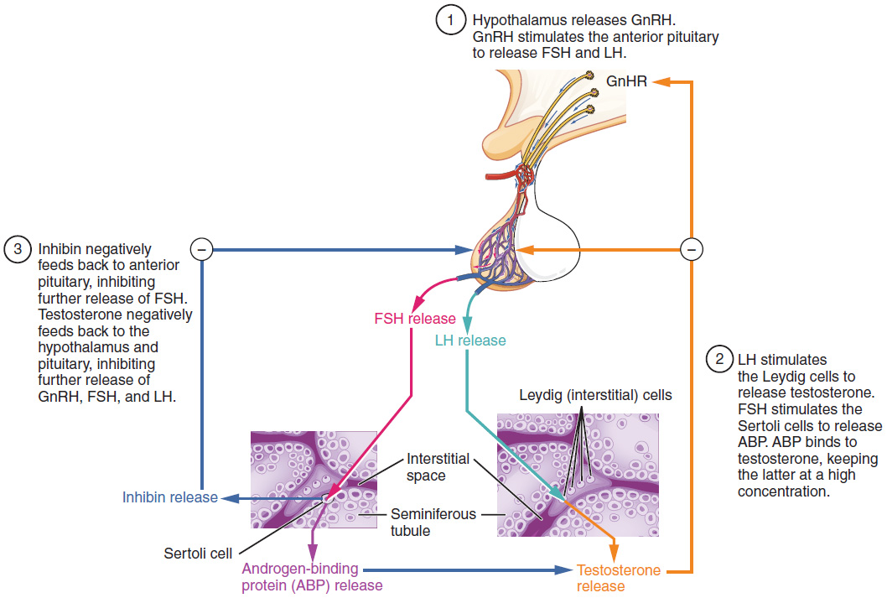

    - Testicular Steroidogenesis
Testosterone (T) is the most important local and systemic androgen produced by the testis. T concentrations are similar by race and ethnicity, but decline with increased abdominal visceral fat and with age. Leydig cells are located in the interstitial compartment of the testis, which allows secretion of T and E2 into seminiferous tubules, gonadal lymphatics and venules. Testosterone is synthesized from cholesterol through sequential reactions that are catalyzed by cytochrome P450-containing complexes (1).
In men, gonadal steroidogenesis accounts for over 95% of T production with the remainder produced by the adrenal gland and extraglandular conversion of the weak androgenic precursors, dehydroepiandrosterone and androstenedione to T. T production in young men averages 15 to 30µmol (4 to 9 mg) per day. About 45% of blood T is bound to high-affinity Sex Hormone-Binding Globulin SHBG, 4% to corticosteroid-binding globulin, and the remaining 50% to lower-affinity high-capacity binding proteins, such as albumin. Approximately 1% to 2% remains free-unbound (1).
Androgens are crucial for male reproduction and general health. Testosterone triggers the development of male secondary sexual characteristics at puberty, maintains adult sexual behavior and function, and drives late stages of spermatogenesis independently of its metabolite 5a-dihydrotestosterone (DHT). Untransformed T exerts potent anabolic effects. T also functions as a prohormone, which undergoes conversion to other steroids, such as E2 and DHT. By being reduced or aromatized, T may oppose or potentiate the actions of E2 on certain genes (1).
    - Physiology of Hypothalamo-Pituitary-Testicular Network
None of kisspeptin, GnRH, LH, or T acts alone. Rather all four signals are interlinked in a network or ensemble. Pulsatile GnRH secretion drives pulsatile LH secretion, which stimulates pulsatile T production. Direct sampling of human spermatic-vein blood suggests that: (1) T feeds back onto both LH and FSH secretion within 30 to 45 minutes (LH) or longer (FSH); (2) LH, but not FSH, feeds forward onto T secretion after a delay of 40 to 90 minutes; and (3) secreted T distributes rapidly among free (aqueous), albumin-bound and SHBG-bound compartments(1).
Both GnRH outflow and LH secretion are subject to feedback inhibition by T and E2. T feedback is substantially but not completely mediated by aromatization to E2 systemically and/or within the hypothalamo-pituitary unit. Exogenous E2 by acting on the pituitary reduces LH pulse amplitude without altering pulse frequency whereas exogenous T by acting on the hypothalamus and the pituitary gland decreases GnRH-LH pulse frequency and amplitude (1).
    - Feedback control of gonadotropin
The HPG system is a closed-loop feedback system directed at maintaining normal reproductive function. Gonadal hormones have inhibitory effects on the secretion of LH and FSH. Although testosterone the major secretory product of the testes is a primary inhibitor of LH secretion in men, other testes products, including estrogens and other androgens, also inhibit LH secretion. Testosterone is metabolized in peripheral tissues to the potent androgen dihydrotestosterone (DHT) or potent estrogen, estradiol. Both androgens and estrogens independently appear to modulate LH secretion. Estradiol is produced both by the testes and from peripheral conversion of androgenic precursors and is a more potent inhibitor of LH and FSH secretion. Gonadal sex steroids influence the frequency and/or amplitude of LH secretory pulses in men by acting at the level of the GnRH pulse generator in the hypothalamus and partly at the level of GnRH-stimulated LH secretion. Like LH, both testosterone and estradiol are capable of suppressing FSH serum levels, but the influence of these two gonadal steroids in physiological function is still undefined (43).
Exercise is associated with release of a number of pituitary and hypothalamic hormones and a decline in the concentration of LH. FSH is generally not influenced by exercise. Serum inhibin concentrations, which are reciprocally influenced by serum FSH concentrations, are increased in some animals but are unchanged after acute exercise in human males. Teleologically, the decline in gonadotrophic hormone (LH) secretion after exercise may be geared to enhance individual survival over species propagation in times of stress, analogous to the postulated 'fight or flight' reaction. The decrease in gonadotrophic hormone (LH) secretion is believed to be due to changes in GnRH pulse frequency and amplitude(60).
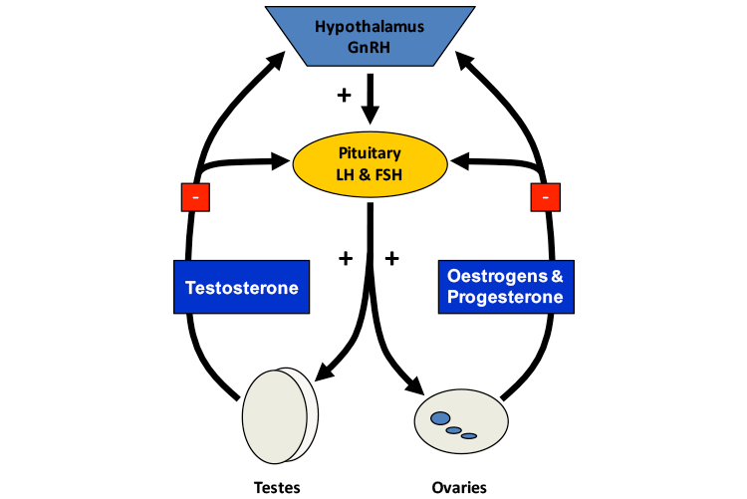

Neuroendocrine regulation of reproductive hormone secretion and release is dependent on pulsatile secretion of the hypothalamic GnRH. This episodic release of GnRH is a function of a hypothalamic pacemaker located in the suprachiasmatic nucleus (GnRH clock). The mammalian reproductive system requires one pulse of GnRH approximately every hour. If this occurs, reproductive cycles occur in females and males are fertile(60).
    - Gonadotropin-Releasing Hormone
Sexual activity and receptiveness usually start at puberty, when GnRH neurons in the hypothalamus resume a pulsatile activity stimulating gonadotropin production and sex steroid secretion. Consequently, high-frequency GnRH release activates the hypothalamic–pituitary–gonadal (HPG) axis leading to sexual maturation and secretion of gonadal steroid hormones, which, in turn, exert a feedback control on GnRH secreting hypothalamic function(61).
Mammalian GnRH (termed GnRH-I) is a decapeptide (pGlu-His-Trp-Ser-Tyr-Gly-Leu-Arg-Pro-Gly-NH2) that plays a key role in the process of reproduction. It is produced by hypothalamic neurosecretory cells and released in a pulsatile manner into the hypothalamo-hypophyseal portal circulation, through which the hormone is transported to the anterior pituitary gland. After binding to its cognate receptor (type I GnRH receptor) on pituitary gonadotropes, the hormone stimulates the biosynthesis and secretion of LH and FSH, which in turn regulate gonadal steroidogenesis and gametogenesis in both sexes. In addition to this well-known endocrine function, it has become evident that GnRH-I is a potentially important autocrine and/or paracrine regulator in some extrapituitary compartments such as the ovary, placenta, uterus, and immune system. GnRH-I functions as an autocrine and/or paracrine factor in a number of extrapituitary compartments, where it regulates steroidogenesis, cell proliferation, apoptosis, and embryo implantation(62).
Until now, more than a dozen isoforms of GnRH sharing 10–50% amino acid identity have been found in vertebrates (14). It is generally thought that most vertebrate species possess at least two, and usually three, forms of GnRH, which differ in their amino acid sequences, localizations, and embryonic origins. In addition to GnRH-I, a second GnRH subtype (termed GnRH-II) that was originally identified from chicken hypothalamus has been found in humans(62).
Tissue distribution in humans
Brain. The most prominent difference in the tissue distribution of GnRH-I and GnRH-II in humans is that the latter isoform is expressed at the highest level outside the brain. The levels of GnRH-II mRNA in the kidney are approximately 30-fold higher than in any brain region, whereas the expression in the bone marrow and prostate is about 4-fold greater than in the brain. Conversely, GnRH-I expression was not observed at a high level outside the brain. In humans, cell bodies of GnRH-I neurons are concentrated in the preoptic area and basal hypothalamus. However, they can also be found in the septal region and anterior olfactory area, as well as the cortical and medial amygdaloid nuclei(62).
Placenta. It has long been shown that human placenta in vitro synthesizes and secretes GnRH-I that is immunologically indistinguishable from its hypothalamic counterpart. Likewise, Siler-Khodr and Grayson have shown that GnRH-II is released from human placenta in vitro in a pulsatile fashion and that this second GnRH form is more resistant than GnRH-I to degradation by placental enzymes(62).
Uterus. Expression of GnRH-I mRNA has been demonstrated in virtually all human uterine compartments(62).
Ovary. Expression of GnRH-I and GnRH-II mRNAs identical to their brain counterparts has been demonstrated in various human ovarian tissues(62). Both forms of GnRH are expressed in normal human breast tissue and are overexpressed in breast cancer. Moreover, certain immune cell lineages such as T lymphocytes and peripheral blood mononuclear cells have been found to produce GnRH-I or both GnRH-I and GnRH-II(62).
    - Luteinizing Hormone (LH)
LH is a glycoprotein consisting of α (89 amino acids) and β (115 amino acids) subunits. Secreted from basophilic cells of the anterior pituitary, LH is the primary regulator of testosterone secretion from the Leydig cells of the testes. The androgenic regulating properties of LH are contained entirely in the β subunit, while the α subunit of LH is identical to that of other anterior pituitary glycoproteins (follicle-stimulating hormone and thyrotropin). High affinity binding of LH at the Leydig cells of the testes activates a cyclic adenosine monophosphate (cAMP) mechanism, resulting in increased testosterone synthesis. This activation is dependent on the frequency and amplitude of LH pulsatility, with pulses occurring in the human at the rate of approximately 8 to14 pulses/day in men. Secretion of LH is principally regulated by LH releasing hormone (LHRH) via portal circulation from the hypothalamus. High affinity binding of LHRH in the anterior pituitary activates LH secretion by a calcium-dependent mechanism, resulting in LH secretion in a pulsatile manner. Negative feedback of testosterone acts to modulate LHRH and LH secretion in the hypothalamic pituitary axis. LH levels are positively related to the volume and intensity of the resistance exercise stress(63).
    - Follicle-stimulating hormone FSH
FSH is a 35.5 kDa glycoprotein heterodimer, consisting of two polypeptide units, alpha and beta. Its structure is similar to those of LH, thyroid-stimulating hormone (TSH), and human chorionic gonadotropin (hCG). The alpha subunits of the glycoproteins LH, FSH, TSH, and hCG are identical and consist of about 96 amino acids, while the beta subunits vary. Both subunits are required for biological activity. FSH has a beta subunit of 111 amino acids (FSH β), which confers its specific biologic action, and is responsible for interaction with the follicle-stimulating hormone receptor. FSH is synthesized and secreted by the gonadotropic cells of the anterior pituitary gland, and regulates the development, growth, pubertal maturation, and reproductive processes of the body. In humans, FSH is necessary for the maintenance of quantitatively normal sperm production, FSH receptor expression (FSH-R) is limited to the testicular Sertoli cells, while LH receptors (LH-R) are found primarily in the Leydig cells, although receptor staining is also observed in spermatogenic cells(64).
    - Kisspeptin stimulates GnRH secretion
The Kiss1 gene encodes a family of peptides called kisspeptins, which bind to the Gprotein-coupled receptor GPR54. Kisspeptin(s) and its receptor are expressed in the forebrain. The results from a wide variety of studies indicate that kisspeptin stimulates gonadotropin secretion via a hypothalamic pathway that activates GnRH neurons. Evidence to date suggests that kisspeptin signaling is an essential component of the neuroendocrine reproductive axis and is consistent with the hypothesis that kisspeptin neurons in the forebrain act as gatekeepers to awakening of reproduction at puberty and coordinating reproductive activity during adulthood. Kisspeptin neurons are direct targets of gonadal steroids and may be involved in both the negative and positive feedback regulation of gonadotropin secretion(65). It is well-known that sex steroids exert a regulatory effect on hypothalamic GnRH secretion through both negative and positive feedback mechanisms. kisspeptin/GPR54 signaling could be the central link between sex steroid feedback effects and GnRH secretion(61). The disruption of kisspeptin activity would decrease HPG axis activity and cause reproductive disorders(66).
    - CRH inhibits GnRH secretion
CRH is involved in a variety of physiological functions including regulation of HPA axis activity during stressful periods. CRH neurons are activated in the PVN in response to stress, while activated CRH neurons in the PVN are suppressed by glucocorticoids. Three urocortins (Ucns) are known to be members of the CRH family peptides: Ucn1 is a 40 amino acid peptide, Ucn2 and Ucn3 have been identified in the human genome. Ucn1 and Ucn3 are expressed in various human tissues, whereas Ucn2 is found in human endometrium or gestational tissues. CRH and Ucns mediate stress responses, cardiovascular function, and immune functions via CRH receptors. The effects of the CRH/Ucn-related peptides are mediated by G protein-coupled seven transmembrane receptors. Two major subtypes of CRF receptors, type 1(CRH1 receptor) and type2 (CRH2 receptor)(67).
CRH inhibits appetite and activates thermogenesis via the catecholaminergic system. Also, reciprocal interactions exist between the amygdala and the hippocampus and the stress system, which stimulates these elements and is regulated by them. CRH plays an important role in inhibiting GnRH secretion during stress, CRH suppresses the GnRH neurons of the arcuate nucleus of the hypothalamus, while, via somatostatin, it also inhibits GH, TRH and TSH secretion, suppressing, thus, the reproductive, growth and thyroid functions . Central CRH, via glucocorticoids and catecholamines, inhibits the inflammatory reaction, while directly secreted by peripheral nerves CRH stimulates local inflammation (immune CRH). Chronicity of stress system activation would lead to the syndromal state. Because CRH coordinates behavioral, neuroendocrine and autonomic adaptation during stressful situations, increased and prolonged production of CRH could explain the pathogenesis of the syndrome(68).
    - Glucocorticoids
The end-hormones of the HPA axis, glucocorticoids, have multiple roles Glucocorticoids exert inhibitory effects at the levels of the GnRH neuron, the pituitary gonadotroph, and the gonads themselves and render target tissues of sex steroids resistant to these hormones. They also have direct as well as insulin-mediated effects on adipose tissue, ultimately promoting visceral adiposity, insulin resistance, dyslipidemia and hypertension (metabolic syndrome X) and direct effects on the bone, causing ‘‘low turnover’’ osteoporosis. Suppression of gonadal function caused by chronic HPA axis activation has been demonstrated in highly trained athletes of both sexes. Thus, glucocorticoids antagonize the beneficial actions of GH and sex steroids on fat tissue (lipolysis) and muscle and bone anabolism. Chronic activation of the stress system would be expected to increase visceral adiposity, decrease lean body (muscle and bone) mass and suppress osteoblastic activity. The inhibitory glucocorticoid feedback on the ACTH secretory response acts to limit the duration of the total tissue exposure to glucocorticoids, thus, minimizing the catabolic, anti-reproductive and immunosuppressive effects of these hormones(68). Glucocorticoids inhibit testosterone production by Leydig cells. In addition, experimental evidence suggests that chronic stress may further decrease LH secretion. These changes result in diminished libido and fertility(69).

CRH/AVP
The principal hypothalamic stimulus to the pituitary–adrenal axis is CRH, AVP is a potent synergistic factor with CRH in stimulating ACTH secretion; however, AVP has little ACTH secretagogue activity alone. Furthermore, it appears that there is a reciprocal positive interaction between CRH and AVP at the level of the hypothalamus, with each neuropeptide stimulating the secretion of the other. In non-stressful situations, both CRH and AVP are secreted in the portal system in a circadian, pulsatile fashion, with a frequency of about two to three secretory episodes per hour. Under resting conditions, the amplitude of the CRH and AVP pulses increase in the early morning hours, resulting finally in ACTH and cortisol secretory bursts in the general circulation. These diurnal variations are perturbed by changes in lighting, feeding schedules and activity and are disrupted by stress. During acute stress, the amplitude and synchronization of the CRH and AVP pulsations in the hypophyseal portal system markedly increases, resulting in increases of ACTH and cortisol secretory episodes. Depending on the type of stress, other factors such as AVP of magnocellular neuron origin, angiotensin II and various cytokines and lipid mediators of inflammation are secreted and act on hypothalamic, pituitary or adrenal components of the HPA axis, potentiating its activity(68).

  - Effects of Exercise on the Neuroendocrine Components of the Reproductive Axis
Indeed, increasing the amount of physical activity is associated with extensive health improvements. However, strenuous exercise represents a physical stress that challenges homeostasis. In response to this stressor, the endocrine and nervous systems are known to react and participate in the maintenance of homeostasis and the development of physical fitness. Regardless of the many known health benefits of exercise, there is a body of evidence suggesting that endurance exercise is associated with some health problems. In recent years, prolonged strenuous exercise has been proposed as a possible reason for male factor infertility (41).exercise affects several testis functions, from spermatogenesis to hormone production (39).
    - Stress and reproduction, a generally negative relationship
Reproductive functions and stress regulation systems are closely linked in most species. Generally, reproductive functions are temporarily suppressed by various kinds of stress, such as infection, psychological burdens, excess exercise, and undernutrition, in humans and animals because reproduction, which requires a large amount of energy, is not essential for survival. Although reproductive functions are usually restored immediately after stress levels reduce, prolonged or excessive stress can sometimes have negative long-term consequences. Reproductive functions are mainly regulated by the HPG axis(66). Under nonstress condition, hormones of HPA axis actually enhance reproduction and may play a critical role in managing energy income and use during reproductive process(70).
Stress-related hormones can influence sexual functions at all three levels of the HPG axis: the brain (to inhibit GnRH secretion), the pituitary (to interfere with GnRH-induced LH release), and the gonads (to alter the stimulatory effect of gonadotropins on sex steroid secretion)(71).
    - Stress and reproductive suppression in male:
In mammals stress disrupts male reproductive physiology and behavior in three broad ways: a) inhibition of hormones of the gonadal axis, b) impairment of erectile function, c) damping of reproductive and receptive behavior(70).
At the endocrine level, stress-induced released of β-endorphin has inhibitory effects upon GnRH release, such that there is a decline of GnRH concentration in the hypophysial-pitutiary portal system within seconds. In addition there is decreased sensitivity of pituitary gonadotropes to GnRH, thus greatly reducing the amount of LH secreted. Finally glucocorticostreiods act as the level of gonads to decrease responsiveness to LH. The result of this is a decline in testosterone levels over the course of minutes to hours in response to a variety physical and psychological stressors(70).

    - Exercise training and spermatogenesis
There is evidence that exercise training produces divergent effects on spermatogenesis. On one hand, long-term endurance exercise training is associated with decreased production of testosterone, and consequently spermatogenesis is impaired. On the other hand, moderate volunteer exercise training, attenuates the age-associated impairment in spermatogenesis. After chronic exercise, a decrease in the activity of sorbitol dehydrogenase (SDH) enzyme occurs. Since SDH converts sorbitol into fructose and spermatogonia and spermatozoa use glucose and fructose as main energy sources, it is not surprising that the lack of SDH can affect spermatogenesis (39).
Another protein affected by exercise training is the outer dense fiber 1 (ODF1). ODF1 is involved in spermatozoa morphogenesis, more specifically in the process of head and tail junction. With exercise, ODF1 expression decreases, leading to incomplete morphogenesis (tails separated from heads) and, consequently, to impaired spermatogenesis (39).
    - Effect of exercise on testicular function
Exercise training might positively or negatively influence andrological health depending upon the type, intensity and duration of the training program, and on individual health status (63). Previous studies demonstrate that exercise training has a strong influence in testosterone biosynthesis. Acute and intense exercise training leads to an increase in testosterone levels, while chronic and intense exercise training decreases testosterone levels due to subclinical inhibition of normal reproductive function (39).
It has been reported that both hypothalamic and testicular endocrine functions are suppressed during acute prolonged physical exercise. The exercise-induced suppression of serum testosterone is associated with suppressed endogenous GnRH stimulation of gonadotropin release during exercise. Qualitatively and quantitatively normal spermatogenesis is critically dependent on an intact hypothalamus–pituitary–testis (HPT) axis (41).

High‑intensity exercise training
There is a general awareness that high-intensity exercise training is harmful to testicular function. Male athletes, particularly long-distance runners, have been shown to have reduced testosterone levels. In addition, elevated scrotal temperature associated with certain types of exercise may cause atrophy of the testicular germinal epithelium and adversely affect spermatogenesis. Bicycle riding has been linked to several genitourinary problems, and two studies among competitive cyclists reported changes in semen parameters, including abnormal sperm morphology and reduced sperm motility during periods of racing. Few studies that have shown significant alterations in sperm count, concentration, motility, and morphology among endurance trained runners, high-mileage runners, and high-intensity long-term treadmill runner (63, 64).

Moderate‑intensity exercise training
Several population-based studies reported a positive association between moderate-intensity aerobic exercise training and testis function parameters such as sperm concentration and hormonal serum levels. Indeed, increased serum levels of total and free testosterone, sperm count, motility and morphology were observed in trained subjects (63).
    - Exercise training and hormones
Exercise presents a serious challenge to the homeostasis of the body. In response to strenuous exercise, there is an enhanced secretion of cortisol, stimulated by increased release of ACTH which serves to mobilize fuel stores and CRH-induced proopiomelanocortin peptides, such as β-endorphin, and inhibits hypothalamic GnRH secretion. In addition, glucocorticoids suppress gonadal axis function at the hypothalamic–pituitary level. CRH and its receptors have also been identified in the Leydig cells of the testis, where CRH exerts inhibitory actions on testosterone biosynthesis. In fact, CRH hyperactivity is inferred to be associated with the overtraining syndrome (38). The data analyzed suggest that exercise training influences both the HPG axis and the Leydig cells themselves, leading to a testicular dysfunction characterized by a decrease on testosterone production Since testosterone controls spermatogenesis, this process is also affected, resulting in spermatozoa defects and impaired male fertility(39).
Prolactin, a stress hormone produced in the pituitary gland, may also be involved in regulation of testicular sex steroid production. Hyperprolactinaemia is amongst the endocrine disorders known to influence male infertility. Hyperprolactinaemia in men is defined by the presence of a high serum prolactin level of >15 mg/L. It can result from physiological or pathological conditions. Stress and exercise can cause small increases in prolactin levels and are important causes of physiological hyperprolactinaemia. Prolactin inhibits pulsatile GnRH secretion and consequently inhibits the pulsatile release of FSH, LH and testosterone. This results in marked effects on spermatogenesis ranging from alteration in sperm quality to complete spermatogenic arrest. Studies have identified prolactin receptors on Leydig cells, Sertoli cells and epithelial cells of efferent ducts, suggesting a potential role for prolactin in promoting steroidogenesis, spermatogenesis and secretory/adsorptive functions of male reproductive organs(72).
    - Exercise training and Reactive oxygen species
Reactive oxygen species (ROS) produced in metabolic and physiological processes and harmful oxidative reactions may lead to oxidation of biological molecules such as lipids, proteins, and DNA. There is a body of evidence suggesting that endurance exercise is associated with oxidative stress. During the resting state, the human body produces ROS continuously, but in healthy individuals these ROS are produced at levels well within the capacity of the body’s antioxidant defense system (41). Several enzymes in the antioxidant system are profoundly affected by exercise training. In general, chronic exercise training, either swimming or running, decrease the antioxidant capacity in testis(37).During endurance exercise, there is a 10 to 20 fold increase in whole body oxygen (O2) consumption and O2 uptake in the active skeletal muscle increases 100 to 200 fold. This increase in O2 utilization may result in the production of ROS at the rates that exceed the body’s capacity to detoxify them. However, some studies have failed to observe exercise-induced oxidative stress. An increase in the formation of ROS decreases fertility, as the ROS will attack the membranes of the spermatozoa, decreasing their viability. Altogether these can impair spermatogenesis and fertility capacity in men. The presence of high ROS levels has been reported in the semen of between 25 and 40% of infertile men. This is because ROS, at high levels, are potentially toxic to sperm quality and function. Therefore, persistent ROS formation during continuous strenuous exercise might be harmful for normal spermatogenesis (41).
    - Exercise training and apoptosis
There is evidence that exercise training modulates several factors, which may alter apoptosis in a variety of tissues. ROS produced during exercise training interact with intracellular and extracellular proteins and trigger apoptosis, which in turn is a vital regulatory process of male germ cell development (30).
    - Intratesticular temperature
Also the intratesticular temperature should be lower than the core temperature for normal sperm production. External heating of the testes for short periods of time results in a dramatic but temporary decrease in sperm count after a delay of 6–8 weeks. The adverse effect of physical stress might be the result of increased body temperature compromising testicular thermoregulation during strenuous exercise. Testicular heating, ROS formation, and gonadotropin suppression are all contributing factors to semen changes (41).
Excessive exercise in the absence of eating disorders can result in hypogonadotropic hypogonadism due to hypothalamic dysfunction in men, with reductions in both gonadotropins and total and free testosterone levels that correlate with the intensity of endurance exercise High-mileage endurance exercise can also affect sperm count, density, motility, and morphology on semen analysis. Unlike endurance exercise, resistance exercise is associated with transient increases in androgens and dehydroepiandrosterone sulfate in men (1).

Reference

1. Strauss JF, Barbieri RL. Yen & Jaffe's Reproductive Endocrinology E-Book: Physiology, Pathophysiology, and Clinical Management: Elsevier Health Sciences; 2013.
2. Bornstein SR, Engeland WC, Ehrhart-Bornstein M, Herman JP. Dissociation of ACTH and glucocorticoids. Trends in Endocrinology & Metabolism. 2008;19(5):175-80.
3. Majzoub JA. Corticotropin-releasing hormone physiology. European Journal of Endocrinology. 2006;155(suppl 1):S71-S6.
4. Goel N, Workman JL, Lee TT, Innala L, Viau V. Sex differences in the HPA axis. Comprehensive Physiology. 2011;4(3):1121-55.
5. Viau V. Functional cross‐talk between the hypothalamic‐pituitary‐gonadal and‐adrenal axes. Journal of neuroendocrinology. 2002;14(6):506-13.
6. Spiga F, Walker JJ, Terry JR, Lightman SL. HPA axis‐rhythms. Comprehensive Physiology. 2011;4(3):1273-98.
7. Vamvakopoulos NC, Chrousos GP. Evidence of direct estrogenic regulation of human corticotropin-releasing hormone gene expression. Potential implications for the sexual dimophism of the stress response and immune/inflammatory reaction. The Journal of clinical investigation. 1993;92(4):1896-902.
8. Gallagher JP, Orozco-Cabal LF, Liu J, Shinnick-Gallagher P. Synaptic physiology of central CRH system. European journal of pharmacology. 2008;583(2-3):215-25.
9. Kyrou I, Tsigos C. Stress hormones: physiological stress and regulation of metabolism. Current opinion in pharmacology. 2009;9(6):787-93.
10. Brunson KL, Khan N, Eghbal‐Ahmadi M, Baram TZ. Corticotropin (ACTH) acts directly on amygdala neurons to down‐regulate corticotropin‐releasing hormone gene expression. Annals of neurology. 2001;49(3):304-12.
11. Panagiotakopoulos L, Neigh GN. Development of the HPA axis: where and when do sex differences manifest? Frontiers in neuroendocrinology. 2014;35(3):285-302.
12. Avram AS, Avram MM, James WD. Subcutaneous fat in normal and diseased states: 2. Anatomy and physiology of white and brown adipose tissue. Journal of the American Academy of Dermatology. 2005;53(4):671-83.
13. Mohamed-Ali V, Pinkney J, Coppack S. Adipose tissue as an endocrine and paracrine organ. International journal of obesity. 1998;22(12):1145.
14. Heaton JM. The distribution of brown adipose tissue in the human. Journal of anatomy. 1972;112(Pt 1):35.
15. Trayhurn P, Beattie JH. Physiological role of adipose tissue: white adipose tissue as an endocrine and secretory organ. Proceedings of the Nutrition Society. 2001;60(3):329-39.
16. Cypess AM, Lehman S, Williams G, Tal I, Rodman D, Goldfine AB, et al. Identification and importance of brown adipose tissue in adult humans. New England Journal of Medicine. 2009;360(15):1509-17.
17. Ronti T, Lupattelli G, Mannarino E. The endocrine function of adipose tissue: an update. Clinical endocrinology. 2006;64(4):355-65.
18. Prolo P, Wong M-L, Licinio J. Leptin. The international journal of biochemistry & cell biology. 1998;30(12):1285-90.
19. Kraemer RR, Chu H, Castracane VD. Leptin and exercise. Experimental Biology and Medicine. 2002;227(9):701-8.
20. Wauters M, Considine RV, Van Gaal LF. Human leptin: from an adipocyte hormone to an endocrine mediator. European journal of endocrinology. 2000;143(3):293-311.
21. Tena-Sempere M, Barreiro M. Leptin in male reproduction: the testis paradigm. Molecular and cellular endocrinology. 2002;188(1-2):9-13.
22. Essig DA, Alderson NL, Ferguson MA, Bartoli WP, Durstine JL. Delayed effects of exercise on the plasma leptin concentration. Metabolism-Clinical and Experimental. 2000;49(3):395-9.
23. Hulver MW, Houmard JA. Plasma leptin and exercise. Sports medicine. 2003;33(7):473-82.
24. Duclos M, Corcuff JB, Ruffie A, Roger P, Manier G. Rapid leptin decrease in immediate post‐exercise recovery. Clinical endocrinology. 1999;50(3):337-42.
25. Ahima RS, Osei SY. Leptin signaling. Physiology & behavior. 2004;81(2):223-41.
26. Stratakis CA, Chrousos GP. Neuroendocrinology and pathophysiology of the stress system. Annals of the New York Academy of Sciences. 1995;771(1):1-18.
27. Bouassida A, Chamari K, Zaouali M, Feki Y, Zbidi A, Tabka Z. Review on leptin and adiponectin responses and adaptations to acute and chronic exercise. British journal of sports medicine. 2010;44(9):620-30.
28. Gaillard R, Spinedi E, Chautard T, Pralong F. Cytokines, Leptin, and the Hypothalamo‐Pituitary‐Adrenal Axis. Annals of the New York Academy of Sciences. 2000;917(1):647-57.
29. Pralong FP, Gaillard RC. Neuroendocrine effects of leptin. Pituitary. 2001;4(1-2):25-32.
30. Bouassida A, Zalleg D, Bouassida S, Zaouali M, Feki Y, Zbidi A, et al. Leptin, its implication in physical exercise and training: a short review. Journal of sports science & medicine. 2006;5(2):172.
31. Yu W, Kimura M, Walczewska A, Karanth S, McCann S. Role of leptin in hypothalamic–pituitary function. Proceedings of the National Academy of Sciences. 1997;94(3):1023-8.
32. Kershaw EE, Flier JS. Adipose tissue as an endocrine organ. The Journal of Clinical Endocrinology & Metabolism. 2004;89(6):2548-56.
33. Siegrist-Kaiser CA, Pauli V, Juge-Aubry CE, Boss O, Pernin A, Chin WW, et al. Direct effects of leptin on brown and white adipose tissue. The journal of clinical investigation. 1997;100(11):2858-64.
34. Tsatsoulis A, Fountoulakis S. The protective role of exercise on stress system dysregulation and comorbidities. Annals of the New York Academy of Sciences. 2006;1083(1):196-213.
35. Blair SN, Kohl HW, Gordon NF, Paffenbarger Jr RS. How much physical activity is good for health? Annual review of public health. 1992;13(1):99-126.
36. Hackney AC. Stress and the neuroendocrine system: the role of exercise as a stressor and modifier of stress. Expert review of endocrinology & metabolism. 2006;1(6):783-92.
37. Gomes M, Freitas MJ, Fardilha M. Physical activity, exercise, and mammalian testis function: Emerging preclinical protein biomarker and integrative biology insights. Omics: a journal of integrative biology. 2015;19(9):499-511.
38. Hackney AC, Moore A, Brownlee K. Testosterone and endurance exercise: development of the âεœexercise-hypogonadal male conditionâε□. Acta Physiologica Hungarica. 2005;92(2):121-37.
39. Houmard JA, Cox JH, MacLean PS, Barakat HA. Effect of short-term exercise training on leptin and insulin action. Metabolism-Clinical and Experimental. 2000;49(7):858-61.
40. Landt M, Lawson GM, Helgeson JM, Davila-Roman VG, Ladenson JH, Jaffe AS, et al. Prolonged exercise decreases serum leptin concentrations. Metabolism-Clinical and Experimental. 1997;46(10):1109-12.
41. Reseland JE, Anderssen SA, Solvoll K, Hjermann I, Urdal P, Holme I, et al. Effect of long-term changes in diet and exercise on plasma leptin concentrations–. The American journal of clinical nutrition. 2001;73(2):240-5.
42. Unal M, Unal DO, Baltaci AK, Mogulkoc R, Kayserilioglu A. Investigation of serum leptin levels in professional male football players and healthy sedentary males. Neuroendocrinology Letters. 2005;26(2):148-51.
43. McClure RD. Endocrinology of male infertility. Office andrology: Springer; 2005. p. 11-37.
44. Kraemer WJ, Ratamess NA, Nindl BC. Recovery responses of testosterone, growth hormone, and IGF-1 after resistance exercise. Journal of Applied Physiology. 2016;122(3):549-58.
45. Ahtiainen JP, Nyman K, Huhtaniemi I, Parviainen T, Helste M, Rannikko A, et al. Effects of resistance training on testosterone metabolism in younger and older men. Experimental gerontology. 2015;69:148-58.
46. Bennell KL, Brukner PD, Malcolm SA. Effect of altered reproductive function and lowered testosterone levels on bone density in male endurance athletes. British journal of sports medicine. 1996;30(3):205-8.
47. Sgrò P, Romanelli F, Felici F, Sansone M, Bianchini S, Buzzachera C, et al. Testosterone responses to standardized short-term sub-maximal and maximal endurance exercises: issues on the dynamic adaptive role of the hypothalamic-pituitary-testicular axis. Journal of endocrinological investigation. 2014;37(1):13-24.
48. Zmuda JM, Thompson PD, Winters SJ. Exercise increases serum testosterone and sex hormone—binding globulin levels in older men. Metabolism-Clinical and Experimental. 1996;45(8):935-9.
49. Wheeler G, Cumming D, Burnham R, Maclean I, Sloley B, Bhambhani Y, et al. Testosterone, cortisol and catecholamine responses to exercise stress and autonomic dysreflexia in elite quadriplegic athletes. Spinal Cord. 1994;32(5):292.
50. Kanaley JA, Weltman JY, Pieper KS, Weltman A, Hartman ML. Cortisol and growth hormone responses to exercise at different times of day. The Journal of Clinical Endocrinology & Metabolism. 2001;86(6):2881-9.
51. Brownlee KK, Moore AW, Hackney AC. Relationship between circulating cortisol and testosterone: influence of physical exercise. Journal of sports science & medicine. 2005;4(1):76.
52. Hill E, Zack E, Battaglini C, Viru M, Viru A, Hackney A. Exercise and circulating cortisol levels: the intensity threshold effect. Journal of endocrinological investigation. 2008;31(7):587-91.
53. Daly W, Seegers C, Rubin D, Dobridge J, Hackney A. Relationship between stress hormones and testosterone with prolonged endurance exercise. European journal of applied physiology. 2005;93(4):375-80.
54. Wideman L, Weltman JY, Hartman ML, Veldhuis JD, Weltman A. Growth hormone release during acute and chronic aerobic and resistance exercise. Sports medicine. 2002;32(15):987-1004.
55. Godfrey RJ, Madgwick Z, Whyte GP. The exercise-induced growth hormone response in athletes. Sports medicine. 2003;33(8):599-613.
56. Weltman A, Weltman JY, Schurrer R, Evans WS, Veldhuis JD, Rogol AD. Endurance training amplifies the pulsatile release of growth hormone: effects of training intensity. Journal of Applied Physiology. 1992;72(6):2188-96.
57. Kraemer WJ, Aguilera BA, Terada M, Newton RU, Lynch JM, Rosendaal G, et al. Responses of IGF-I to endogenous increases in growth hormone after heavy-resistance exercise. Journal of Applied Physiology. 1995;79(4):1310-5.
58. Mejri S, Bchir F, Rayana MB, Hamida JB, Slama CB. Effect of training on GH and IGF-1 responses to a submaximal exercise in football players. European journal of applied physiology. 2005;95(5-6):496-503.
59. Fry A, Kraemer W, Ramsey L. Pituitary-adrenal-gonadal responses to high-intensity resistance exercise overtraining. Journal of Applied Physiology. 1998;85(6):2352-9.
60. Elias A, Wilson A. Exercise and gonadal function. Human reproduction. 1993;8(10):1747-61.
61. Morelli A, Marini M, Mancina R, Luconi M, Vignozzi L, Fibbi B, et al. Sex steroids and leptin regulate the “first Kiss”(KiSS 1/G‐protein‐coupled receptor 54 system) in human gonadotropin‐releasing‐hormone‐secreting neuroblasts. The journal of sexual medicine. 2008;5(5):1097-113.
62. Cheng CK, Leung PC. Molecular biology of gonadotropin-releasing hormone (GnRH)-I, GnRH-II, and their receptors in humans. Endocrine Reviews. 2005;26(2):283-306.
63. Fry AC, Kraemer WJ. Resistance exercise overtraining and overreaching. Sports medicine. 1997;23(2):106-29.
64. Holdcraft RW, Braun RE. Hormonal regulation of spermatogenesis. International journal of andrology. 2004;27(6):335-42.
65. Dungan HM, Clifton DK, Steiner RA. Minireview: kisspeptin neurons as central processors in the regulation of gonadotropin-releasing hormone secretion. Endocrinology. 2006;147(3):1154-8.
66. Iwasa T, Matsuzaki T, Yano K, Mayila Y, Irahara M. The roles of kisspeptin and gonadotropin inhibitory hormone in stress-induced reproductive disorders. Endocrine journal. 2018;65(2):133-40.
67. Kageyama K, Hasegawa G, Akimoto K, Yamagata S, Tamasawa N, Suda T. Differential regulation of gonadotropin-releasing hormone by corticotropin-releasing factor family peptides in hypothalamic N39 cells. Peptides. 2012;33(1):149-55.
68. Tsigos C, Chrousos GP. Hypothalamic–pituitary–adrenal axis, neuroendocrine factors and stress. Journal of psychosomatic research. 2002;53(4):865-71.
69. Kalantaridou S, Zoumakis E, Makrigiannakis A, Lavasidis L, Vrekoussis T, Chrousos G. Corticotropin-releasing hormone, stress and human reproduction: an update. Journal of reproductive immunology. 2010;85(1):33-9.
70. Wingfield J, Sapolsky R. Reproduction and resistance to stress: when and how. Journal of neuroendocrinology. 2003;15(8):711-24.
71. Rivier C, Rivest S. Effect of stress on the activity of the hypothalamic-pituitary-gonadal axis: peripheral and central mechanisms. Biology of reproduction. 1991;45(4):523-32.
72. Dabbous Z, Atkin SL. Hyperprolactinaemia in male infertility: Clinical case scenarios. Arab journal of urology. 2018;16(1):44-52.

